Press release
January 2021

modern basics blue: designs in touch with the latest trends
The first awning fabric collection made from recycled PET

With modern basics blue, weinor has launched the world's first sustainable awning fabric collection made of 85 percent recycled PET. modern basics blue is made of Tempotest Starlight Blue, a sun protection fabric from Parà Tempotest certified according to the Global Recycled Standard (GRS). The collection was developed in a collaboration between the weinor design studio and Parà Tempotest. Compared to conventional awning covers made of polyester, it impresses with a considerably better environmental balance in terms of energy, CO₂ emissions and water consumption. modern basics blue meets the highest quality standards and continues the previous successful modern basics collection with attractive designs for modern outdoor living.

With its new awning fabric collection, weinor is offering the most sustainable awning fabric on the market today, setting new standards in the industry. "60 years of awning and design experience are combined here with 100 years of expertise in textiles from our Italian production partner Parà," says weinor Managing Director Thilo Weiermann. Developed for outdoor use, the awning fabric collection is suitable for all weinor folding arm and conservatory awnings as well as for the Plaza Viva pergola awning and the Paravento side awning. The sustainable fabrics are available exclusively from weinor and can be ordered from February 2021.

"We have launched the project of a sustainable awning fabric together on the basis of many years of working together, successful previous collections and weinor's extensive experience with our spinneret-dyed polyester fabric Tempotest Starlight," reports Matteo Parravicini, Managing Director of Parà. "The modern basics blue collection made of Tempotest Starlight blue is the result of this collaboration."

Sustainable and high-quality sun protection fabric
modern basics blue consists of a high-quality polyester sun protection fabric produced in a sustainable and resource-saving way. It contributes significantly to reducing the ecological footprint, as its production is extremely energy-efficient due to PET recycling: its production uses around 60 percent less energy and causes around 45 percent less CO₂ emissions than the production of other polyester fabrics through the recycling of disposable bottles. The spinneret dyeing used in all weinor awning fabrics also requires around 90 percent less water than conventional yarn or piece dyeing. In terms of its product characteristics, modern basics blue is in no way inferior to the usual durable and permanently brilliant colours of the existing weinor fabric collection.

Top quality materials and features
The recycled base material is food grade PET, a thermoplastic from the polyester family. The fabric's rebound behaviour is improved thanks to the high elasticity of polyester. This results in the best possible fabric stability when the awning is extended. The pigment is already embedded into the fibres during the spinning process by means of a spinneret dyeing process. This means that, unlike with conventional yarn or piece dyeing, the fabric is consistently dyed throughout and therefore remains permanently brilliant in colour. A high-quality Teflon finish makes the fabric insensitive to impurities. The surface is oil, water and dirt-repellent as well as preventing rot. As all the fabrics in the awning cloth collection are made of Tempotest Starlight blue, they are certified according to Oeko-Tex Standard 100 and block around 98 percent of UV radiation with an Ultraviolet Protection Factor (UPF) of 50+.
16 modern patterns for new buyer groups
modern basics blue is a registered trademark. The new awning fabric collection from the weinor design studio comprises 16 modern designs. Like its very successful predecessor collection from weinor's creative workshop, modern basics blue is also aimed at a group of buyers with a clear preference for modern home design. The plain colours based on popular bestsellers focus on timeless shades of grey and sand. New trend colours are also available here, besides the classics. Another plain design in modern petrol picks up on the colour trends in home living. Added to this are plain designs in strong sun colours or elegant silver grey with a new slub effect, a robust structure similar to that of raw linen. These patterns are particularly insensitive and distinguished by a natural look. The popular weinor block designs in shades of grey with contrasting pinstripes are now available in four versions as a 30 cm repeat. As a result, they are also ideal for large systems. For all those who like things a bit livelier, but do not want to do without a contemporary look, weinor offers a new interpretation of classic motifs with very popular creative designs.

Sustainability as part of corporate responsibility
The Italian fabric producer Parà has been investing in sustainable production and environmental protection for a long time. "At the Pontirolo plant, for example, a sewage treatment plant recycles the process water, solar systems supply electricity, and a combined heat and power plant produces heat and steam," reports Matteo Parravicini, "Tempotest Starlight blue is therefore another milestone for Parà to produce in a sustainable, environmentally friendly and resource-saving way." In general, sun and weather protection products are strongly linked to the idea of natural air-conditioning: automated sun protection systems in particular prevent the overheating of living spaces and help reduce the energy required for air conditioning. The special durability of weinor products, which have always been designed for maximum longevity, also contributes to this sustainability concept. The secret behind this is simply high-quality technologies and first-class materials.

"The topic of sustainability and responsibility, or Corporate Social Responsibility, is a consistent thread through many areas of our company," confirms Managing Director Thilo Weiermann. "weinor pays attention to stable growth, the well-being of its employees, the environment at its locations, as well as the environment and climate protection. In each case we have to weigh up which action fits best in view of our overall responsibility. We must develop even more pioneering solutions for our environment," says Weiermann. "We think we are taking a step in the right direction with the fabrics from modern basics blue."

weinor media contact:
Christian Pätz
Weinor GmbH & Co. KG || Mathias-Brüggen-Str. 110 || 50829 Cologne
Email: cpaetz@weinor.de || www.weinor.de
Tel.: +49 (0)221 / 597 09 265 || Fax: +49 (0)221/ 595 11 89
Parà media contact:
Luca Bottaro, Marketing Manager
Parà S.p.A.
Viale Monza 1 || 20845 Sovico (MB) || Italy
Email: luca.bottaro@para.it || www.para.it
Tel: +39 039 2070 || Fax: +39 039 2070425

Image material:

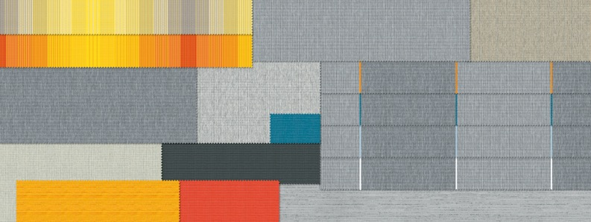
Image 1:
The modern basics blue sustainable fabric collection: 16 new patterns for modern outdoor living

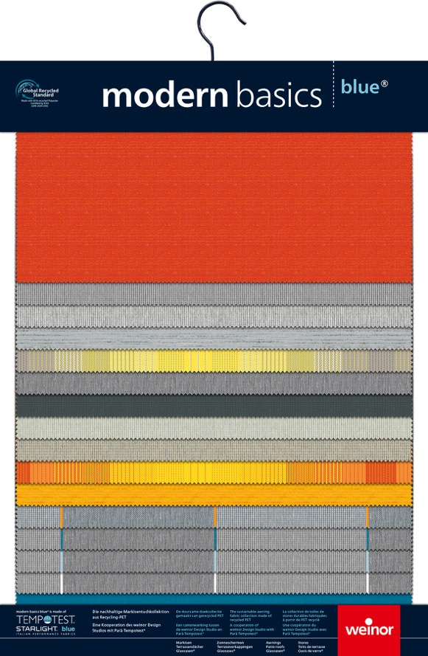

Image 2:
The presentation hanger for the showroom
or the customer meeting on site
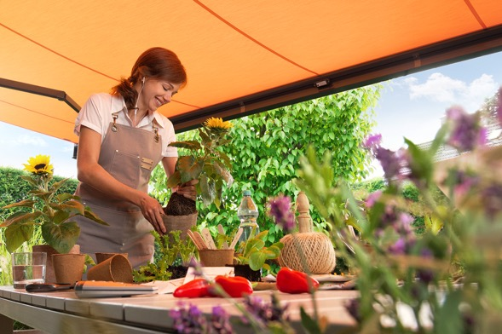
Image 3:
The first collection made of 85 percent recycled PET
based on Tempotest Starlight blue

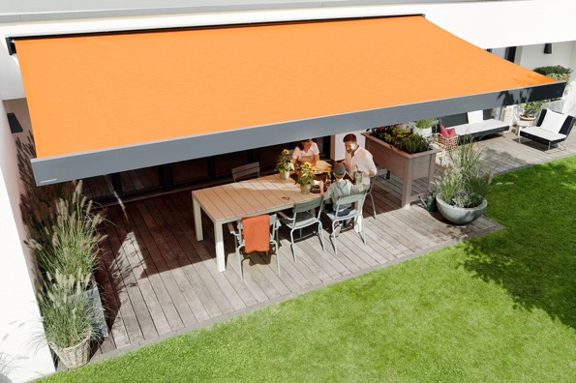
Image 4:
modern basics blue: awning fabrics for new
environmentally conscious groups of buyers

Photos: Weinor GmbH & Co. KG/Parà Tempotest

