Press release
16 June 2021

New production hall is built
weinor expands its plant in Möckern

Just in time for the company’s 30th anniversary at the Möckern site, weinor is expanding its capacities at the production facility in Saxony-Anhalt. The construction of a new state-of-the-art production facility measuring around 7,350 m² is to start this year right next to the existing company building. The plan is for completion in spring 2023.

weinor, the market leader in Northern Europe for sun and weather production on patios, wants to create new space with the modern production hall in order to be fit for the future. Investments are being made for this in plant and machinery that are designed in accordance with the latest ecological and economic guidelines. The ground-breaking ceremony for the project will be held at the end of September 2021.

“We are taking an important step towards the future with our new building,” says plant manager Frank Rappholz. “Taking occupational ergonomic and health aspects into account, we will design the workplaces here to be extremely employee-friendly. We are also guaranteeing that our production will continue to be state of the art and that we are well prepared for future challenges thanks to the expanded capacities. Our retailers will benefit just as much from the new facility as our employees.”

A new building is currently already being erected on the site, which is currently under construction. This is due to be commissioned in July this year and will provide space for offices and sanitary facilities.

About weinor
The weinor products are exclusively available from specialist retail business. The expert for sun and weather protection systems has its head office in Cologne and has been part of the Swiss Griesser Holding AG since 1991.

This text as well as high-resolution images and other information are available at weinor.de/presse/.

weinor media contact:
Christian Pätz
Weinor GmbH & Co. KG || Mathias-Brüggen-Str. 110 || 50829 Cologne
Email: cpaetz@weinor.de || weinor.de
Tel.: +49 (0)221 / 597 09 265 || Fax: +49 (0)221/ 595 11 89

Image material:

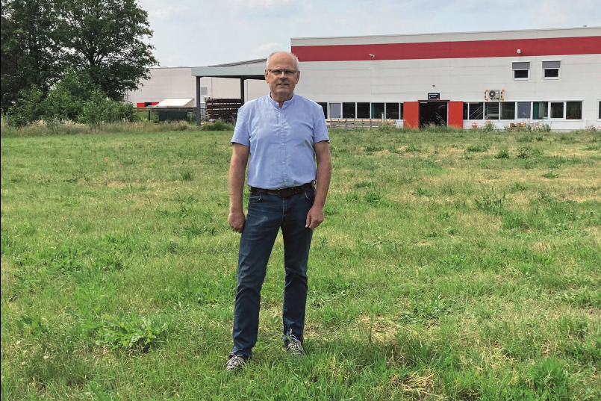
Plant manager Rappholz on the building site for the
future new production hall

Image: weinor

