Press release
February 2023

'my collections 2': innovative awning fabrics from Weinor
The new art of fabric
With its new comprehensive ‘my collections 2’ awning fabric collection, consisting of 171 fabrics, the sun and weather protection expert Weinor presents fully novel weaving technologies and patterns. Twelve patterns exclusively available from Weinor provide a special highlight. Moreover, the recycled PET fabrics introduced last year have been extended as a comprehensive partial collection.
With a variety of colours and structures, the new three-part collection ‘my collections 2’ meets the most different of style preferences. Due to their wealth of varieties, the trendy high-quality acrylic and polyester fabrics are suitable for both modern properties and more classical building types. The awning fabric collection will be available as of February 2023.
Completely new fabric appearance: the exclusive ‘my lines’ fabrics
With the twelve ‘my lines’ awning fabrics, the Weinor Design Studio has created a product innovation which captures the latest living design trends. Whilst current fantasy stripes incorporated simple colour gradients and a clearly recognisable pattern was in the foreground, ‘my lines’ created a completely new fabric appearance with architectonic elegance via its clearly delineated stripes and at the same time radiates atmosphere and homeliness. The novel multi-stripes are only exclusively available from Weinor.
Structured fabric fully meet current trends
In addition to the exclusive series, the fabrics with the novel inner structure are also available single-coloured and with block stripes. As already for several previous collections, the innovative fabrics were developed jointly with the Italian fabric manufacturer Parà Tempotest – a close cooperation partner of the manufacturer for several years.
The woven awning fabric ‘wild silk’ enjoys great popularity amongst the structured fabrics. Vivid textures generate a look similar to natural wild silk. It is now possible for the first time to also realise structures which do not run transversely but follow the line of vision and lead over into the garden as is also the case for the running direction of striped fabrics. The Weinor Design Studio was also involved in this development.
Comprehensive recycled collection for new buyer groups
With modern basics blue, Weinor launched the first sustainable awning fabric collection for outdoor use on the market with sun protection fabric Tempotest Starlight Blue which is certified with 85 percent recycled PET in accordance with the Global Recycled Standard (GRS). With 28 fabrics. it will now be extended to become a comprehensive partial collection for the most varied of customer needs.
The sustainable awning fabrics have already been accoladed with seven prizes, including the Red Dot Design Award and the iF Design Award. Moreover, the innovative collection was awarded the special prize for sustainability within the scope of the R+T Innovation Prize, thus securing a place amongst the finalists for the German Design Sustainability Prize.
As premium quality is the top priority at Weinor, all fabrics – no matter whether acrylic, polyester or recycled PET – are always spinneret-dyed for long-lasting brilliant colours.

Selling made easy with the three-part collection
In order to enable targeted provision for different buyer groups, the new collection is structured with three parts. It incorporates the collection part ‘evermore’ with a large number of timeless fabrics in beige and grey colours, the collection part ’hi hello!’ with colourful pattern as well as ‘modern basics blue’ with sustainable recycled PET fabrics.
As a sales support, Weinor partners can receive both fabric on an individual hanger, a three-part collection binder and the handy compact collection. Diverse advertising materials such as a roll-up display, several posters and the attractive collection printed catalogue draw the customers’ attention to the innovative fabrics. Social media posts and emotional videos are provided for online advertising.

Weinor media contact:
Christian Pätz
Weinor GmbH & Co. KG || Mathias-Brüggen-Str. 110 || D-50829 Köln
E-mail: cpaetz@weinor.de || weinor.com
Tel.: +49 (0)221 / 597 09 265 || Fax: +49 (0)221/ 595 11 89

Image material:
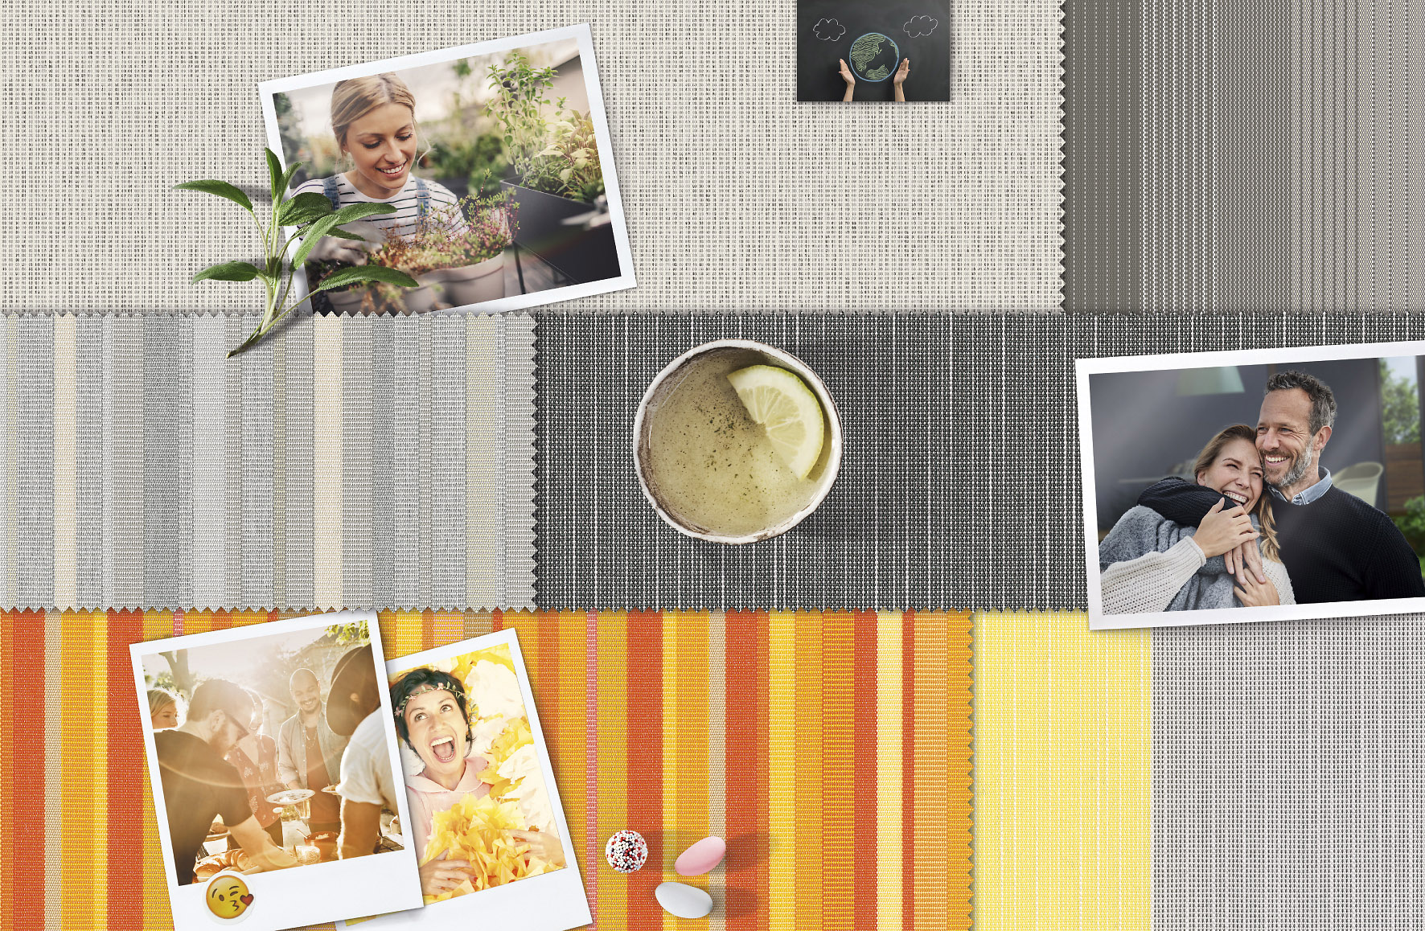
Image 1:
Colour and structure variety: the new
‘my collections 2’ awning fabric collection

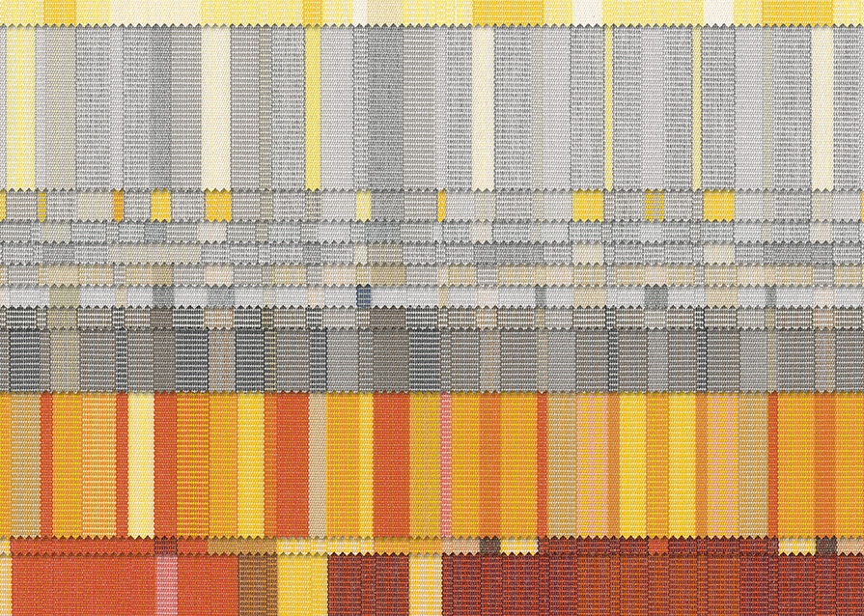

Image 2:
Only from Weinor: 12 exclusive multi-stripes in
timeless or lively colours

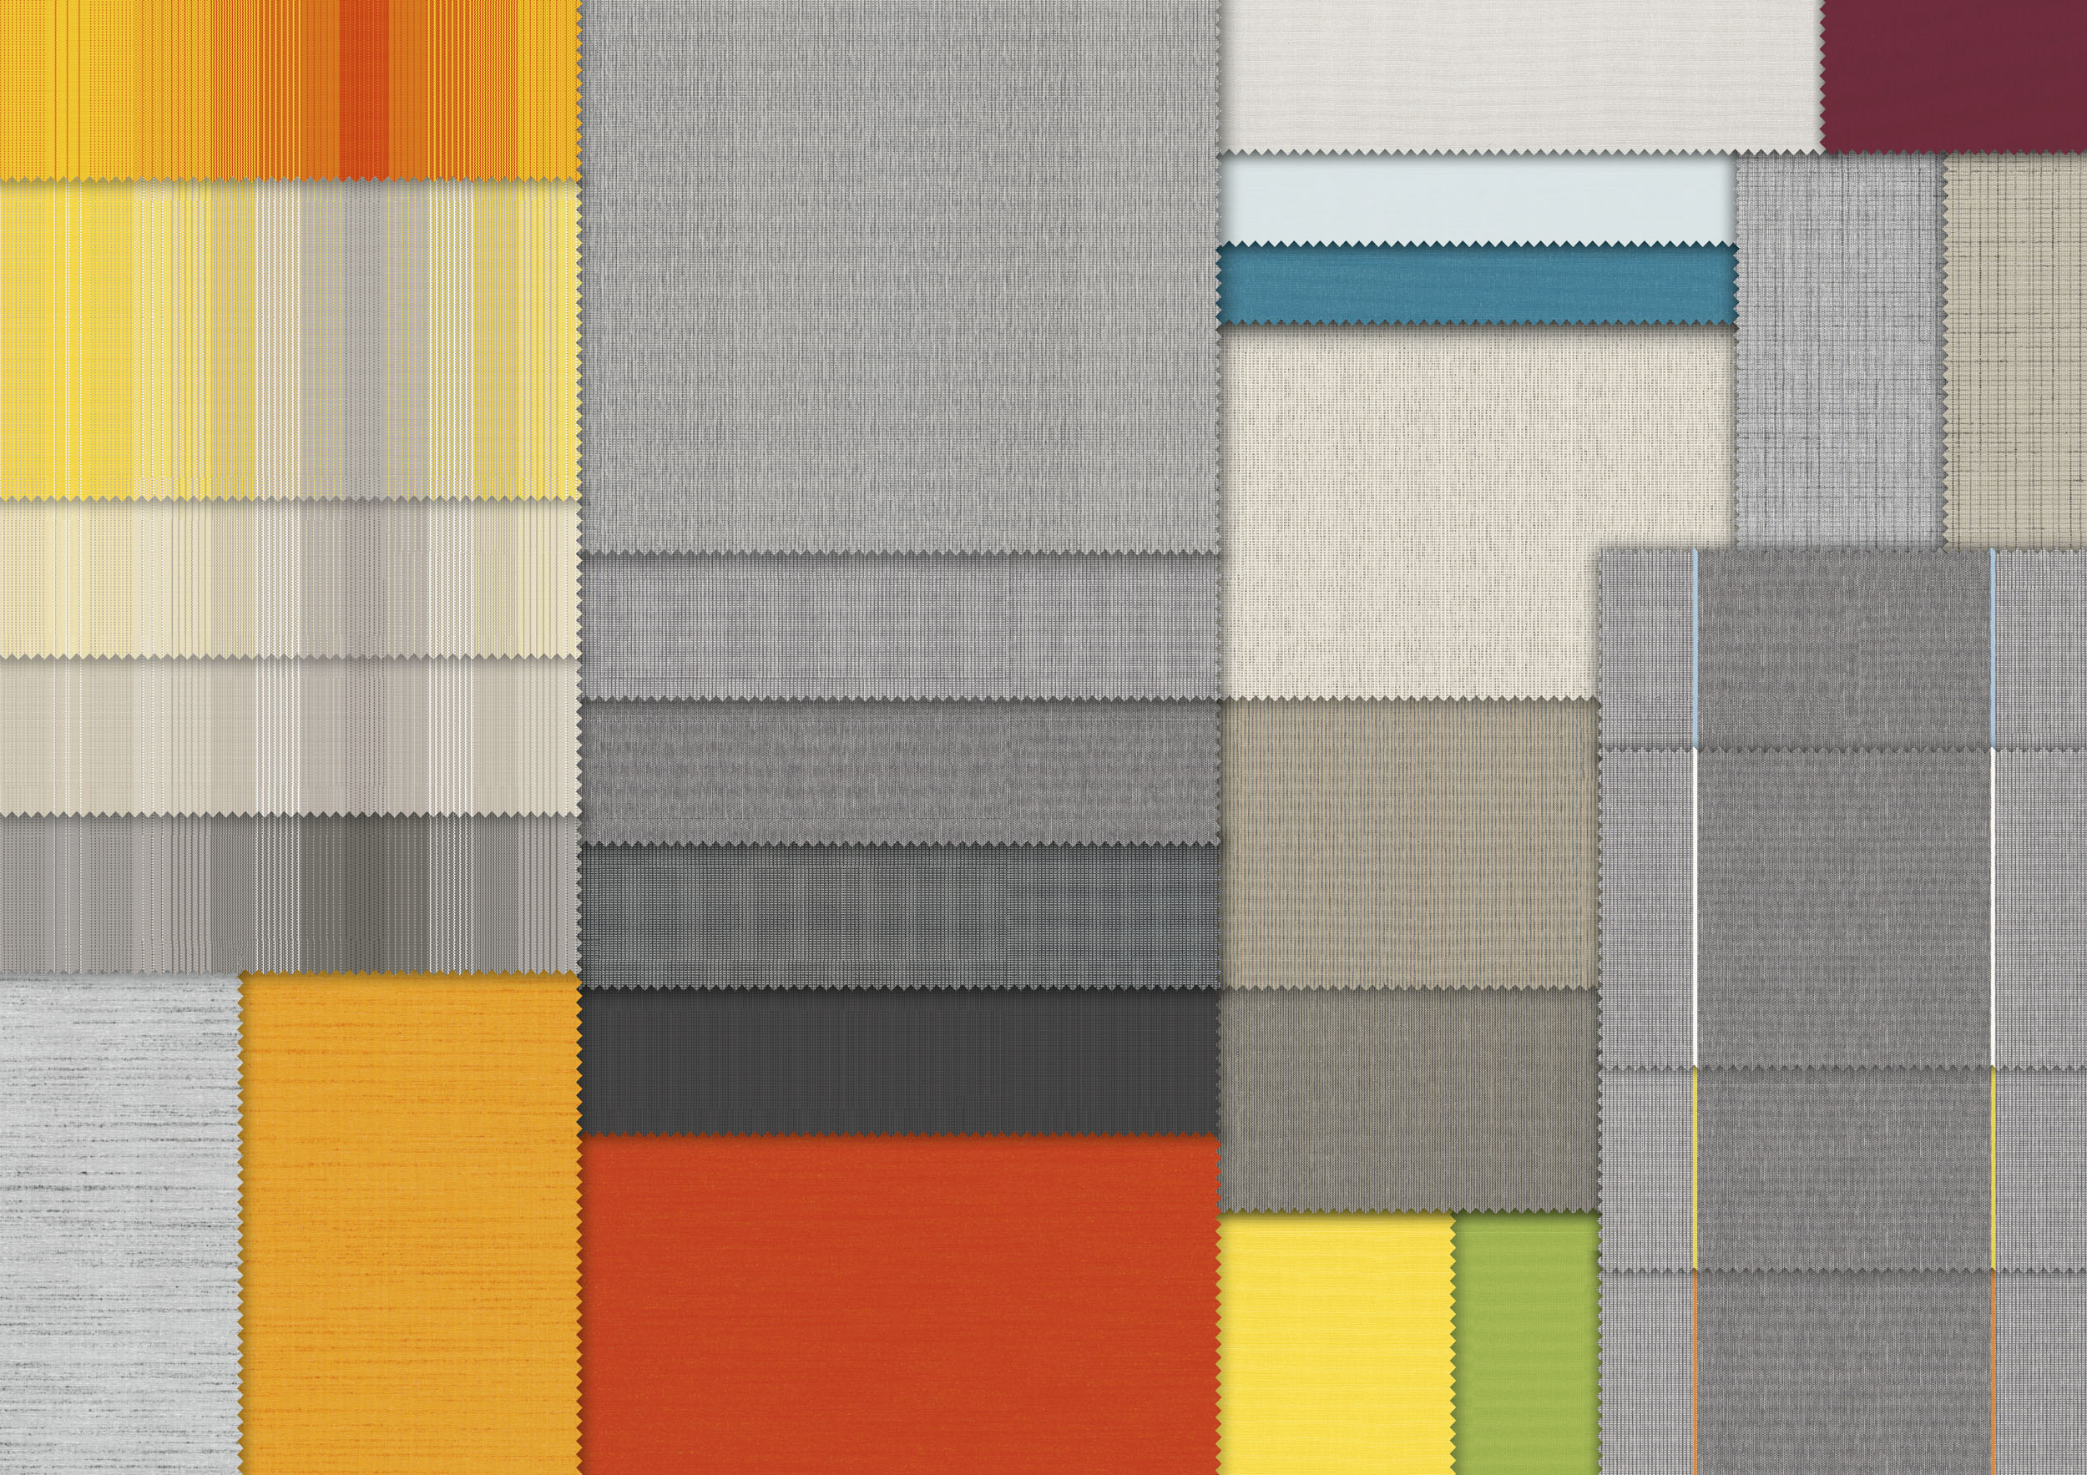
Image 3:
modern basics blue: expansion of the
sustainable awning fabric collection

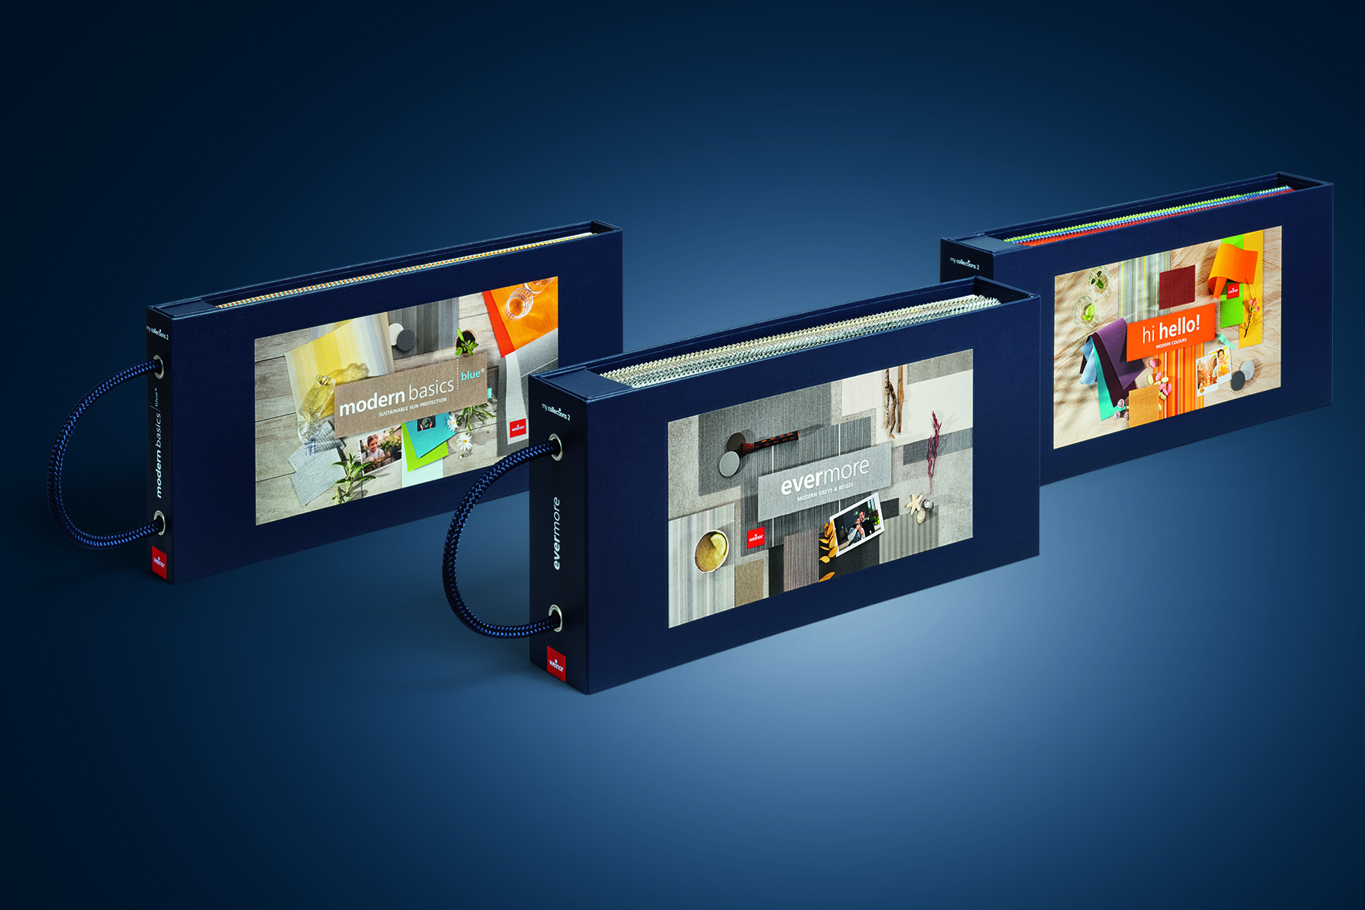

Image 4:
Targeted selling: three-part
collection binders, joined with magnets

Photos: Weinor GmbH & Co. KG

