Press release
May 2021

weinor
Wolfgang Fäßle new commercial director
Wolfgang Fäßle has been the new commercial director at Weinor GmbH & Co. KG since March 2021. He succeeds Angelika Freericks-Jäkel, who has retired after 33 years of successful work.

Wolfgang Fäßle, who holds a degree in business administration, worked for Deutsche Lufthansa AG for 26 years, most recently as Vice President for the Finance Transformation programme. Born in Baden, he worked there as an internationally experienced executive with many years of expertise in managing global organisations and efficiency programmes with a focus on finance and accounting.

As commercial director, the passionate amateur chef and hiker is taking on a variety of tasks at weinor. These include management of the finance, controlling, human resources, real estate and legal departments. Wolfgang Fäßle's key objectives include the further development of the company in the areas of process orientation, digitisation, compliance, corporate governance and transparency. He also wants to play a responsible role in ensuring that weinor continues to grow profitably. "I'm looking forward to the challenges at weinor and see myself first as a goalkeeper who effectively keeps the back-office clear consistent with the rules, but also as a defender who makes one or two important passes. I also make all business management issues my business."

Fäßle's predecessor Angelika Freericks-Jäkel was loyal to the Cologne-based company for 33 years and has now retired. She played a major role in weinor becoming the market leader for sun and weather protection in Northern Europe during this time.

This text as well as high-resolution images and other information are available at weinor.com/press.

Media contact:
Christian Pätz
weinor GmbH & Co. KG || Mathias-Brüggen-Str. 110 || 50829 Cologne
Email: cpaetz@weinor.de || weinor.de
Tel.: 0221 / 597 09 265 || Fax: +49 (0)221/ 595 11 89

Image material:

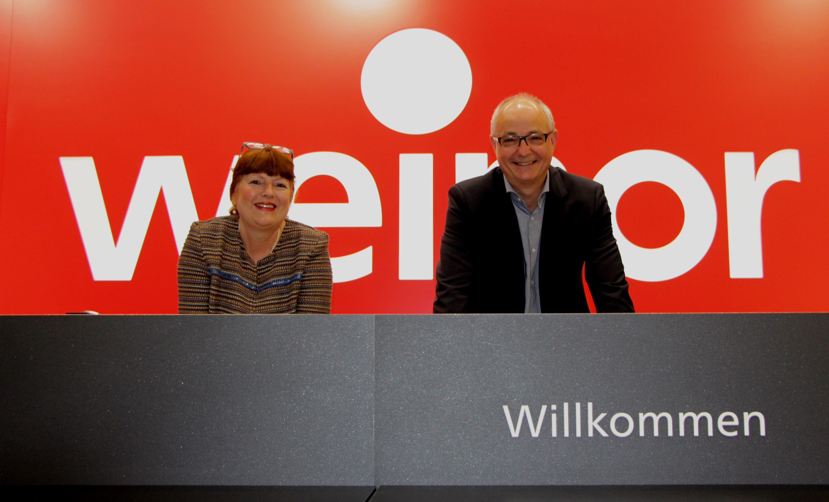
Image 1:
One goes, another steps in: Angelika Freericks-Jäkel hands over the baton to Wolfgang Fäßle.

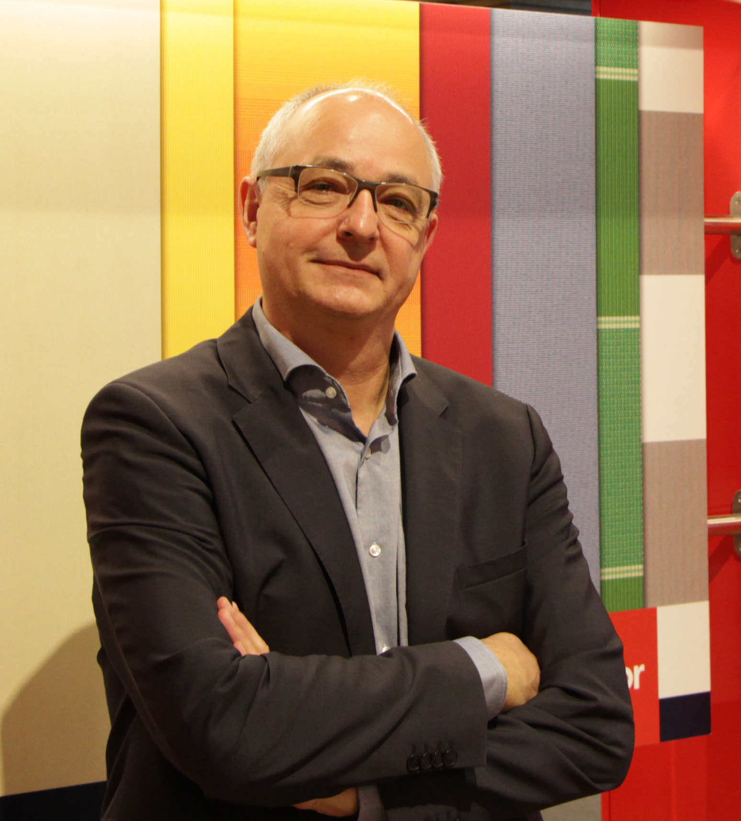
Image 2:
Wolfgang Fäßle, who holds a degree in business administration, held management positions at Deutsche Lufthansa AG for many years.

Photos: Weinor GmbH & Co. KG

