Press release

weinor impresses with Corporate Health Award

weinor receives the Corporate Health Award from the German magazine Handelsblatt and EuPD Research Sustainable Management as a company that is exceptionally committed to its employees’health. Out of the 340 participants, 40 were awarded in total. "We regard health management as one of our central tasks," says Angelika Freericks-Jäkel, Head of Human Resources and Finance at Weinor, "because only healthy and satisfied employees guarantee productivity, innovation and competitiveness. Weinor's health services range from sports activities such as running together or free use of a fitness studio, to ergonomic workplace design with height-adjustable tables, regular preventive medical check-ups or support in coping with stress.

Media contact:
Christian Pätz
Weinor GmbH & Co. KG || Mathias-Brüggen-Str. 110 || 50829 Cologne
Email: cpaetz@Weinor.de || www.weinor.de
Phone: 0221 / 597 09 265 || Fax: 0221/ 595 11 89

This text as well as high-resolution images and other information are available at www.weinor.de/presse/.

Image material:
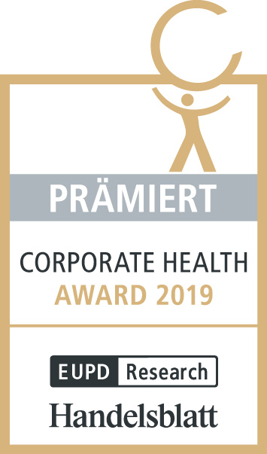

Image:
Top-class award: The seal for outstanding commitment in health management

Photo: weinor GmbH & Co. KG

