Press release

weinor PergoTex II VertiPlus pergola awning
Brilliant design

weinor has developed the VertiPlus faceplate for the visually perfect integration of the VertiTex II Zip 112 vertical awning into the weinor PergoTex II pergola awning. It conceals the rails and vertical awning's cassette corners on the post and is really easily fitted over the corner. The faceplate is available in the construction colour and therefore ensures that the whole construction has a uniform appearance.

Sun and weather protection systems for the patio are becoming more and more sophisticated in their design. Many different construction modules have to be perfectly coordinated with each other in terms of both appearance and technology for everything to work smoothly and have a seamless appearance from a design point of view too. The weinor PergoTex II pergola awning is a good example of this. Integrated LED lighting and guttering as well as a durable, high-quality pull system make it a very popular weinor weather protection. Many patio users don't want to just protect themselves from the weather above though. They are demanding additional weather protection from the front and sides in order to spend more time outdoors. weinor offers vertical awnings and full glass sliding elements for this.

A design faceplate conceals guide rails and cassette corners
As a result, the weinor PergoTex II can be fitted, for example, with the VertiTex II Zip vertical awning all round. Thanks to the zip technology, the sun protection even withstands loads up to wind strength 6. To integrate these kinds of additional applications harmoniously into the contructions's overall appearance, weinor has equipped the PergoTex II VertiPlus with design faceplates that conceal the VertiTex II Zip's guide rails and cassette corners.
Thanks to its in-house powder coating facility, weinor is also able to design the faceplate in the same colour as the aluminium frame. As a result, the combined construction looks like one unit.

Easy installation using clips technology – for retrofitting too
The installation of the design faceplate is extremely simple: it can be attached to the post and roof frame over the corner using clever clips technology. Everything is preassembled making installation quick and easy.
Installation later on is also possible, as is the addition of the construction with glazing elements. The weinor PergoTex II VertiPlus pergola awning is available in three standard designs: with VertiTex Zip 112 all round (front and sides), with VertiTex II Zip 112 just in the front and with VertiTex II Zip 112 in the front and on the right or left. The VertiPlus system can be used for constructions up to six metres wide.

Expected market launch in D, AT, NL, LUX: May 2018

Media contact:
Christian Pätz
Weinor GmbH & Co. KG || Mathias-Brüggen-Str. 110 || 50829 Cologne
Email: cpaetz@Weinor.de || www.weinor.de
Phone: 0221 / 597 09 265 || Fax: 0221/ 595 11 89

This text as well as high-resolution images and other information are available at°www.weinor.de/presse/.

Image material:

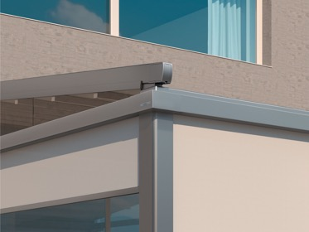
Image 1:
With the weinor PergoTex II VertiPlus, a design faceplate conceals the VertiTex II Zip vertical awning's guide rails and cassette corners.

Photo: Weinor GmbH & Co. KG

