Press release
September 2017

New conservatory awning from weinor
On top form

weinor is launching an innovative new conservatory awning on the market. The Top conservatory awning is replacing the previous WGM 1030 and 2030 models. It has been further developed in terms of both state of the art technology and superb visual appearance. What has remained is the tried and tested tension system with pulley technology. Even multi-section units can be easily installed with the new conservatory awning. Making it the ideal product for both domestic and commercial applications.

The Top conservatory awning's most important properties include flexibility alongside excellent sun protection. Many end users already have a conservatory or patio roof and want to retrofit an awning, or they are building a new terrace or veranda and need a sun shade that can be easily combined. This is where the Top conservatory awning comes into play. Whether it's an insulated or non-insulated conservatory or extension, wooden pergola or aluminum patio roof – the new conservatory awning from weinor can be used universally. The flexible support brackets are an important component in the process. They are available as fixed or adjustable versions. Special versions can also be produced. As a result, the awning height can be adjusted effortlessly to the individual structural conditions – for almost any application.

Reliable tension system
The counterbalance system of the previous 1030 and 2030 conservatory awning models has proved itself thousands of times over. That is why weinor decided to keep this technology with the Top conservatory awning too. Trade companies can therefore rely on the system working reliably for a long time to come. What is new on the other hand is the quiet-operating, tear resistant flat rope. Not only does offer a very quiet operation but thanks to its shape it also prevents the jumping of the round rope, which was often associated with a loud bang. Another improvement is that the new rope is not as prone top fraying.

Elegant look and high wind stability
The Top conservatory awning impresses due to its slim, modern design. As a result, conservatories or patio roofs are complemented by a stylish element that is visually perfectly integrated into the house facade. The Top awning is also available as an OptiStretch version. The fabric is guided securely on four sides in the process. The advantage: taut fabric positioning and no light along the edges. The side edges are also guided smoothly so that they cannot sag. Both the Top conservatory awning versions can remain open up to wind force 6. Even in stronger winds, the sun protection can therefore be used for longer and doesn't have to be retracted at the slightest sign of a breeze.

Easy installation and maintenance
For the technician's everyday work, it is important that the sun protection systems can be installed in teams of two without any problems. That is why weinor has come up with a brilliant idea. If the total weight of the cassette and drop profile is more than 70 kilograms, the two components can be delivered separately. As a result, the installation is much easier on your back. The Top conservatory awning is also advantageous under maintenance aspects. The BiConnect receivers are housed inside the the cassette making it easy to access.

Top conservatory awning: technical data
Max. width: 6.5 m with 5.0 m projection
Max. projection: 6.0 m with 6.0 m width
Wind protection tested up to: wind force 6 on the Beaufort scale and
wind resistance class 3 in accordance with
DIN EN 13561
Motor: as standard
Gear drive: no

Publisher:
Christian Pätz
weinor GmbH & Co. KG || Mathias-Brüggen-Str. 110 || 50829 Cologne
Email: cpaetz@weinor.de || www.weinor.de
Phone: 0221 / 597 09 265 || Fax: 0221/ 595 11 89

Contact:
Simone Lafrenz
Brandrevier GmbH || Gemarkenstraße 138a || 45147 Essen
Email: lafrenz@brandrevier.com || www.brandrevier.com
Phone : +49 (0)201 / 874293 13 || Fax: +49 (0)201 / 874293 29

This text as well as high-resolution images and other information are available at°www.weinor.de/presse/.

Image material:

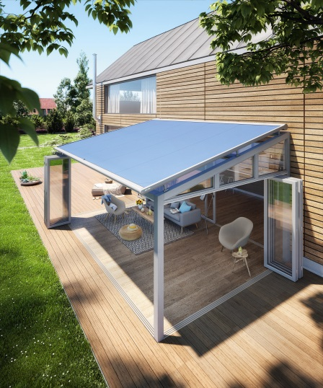
Image 1:
The Top conservatory awning impresses due to its slim, modern design and adapts harmoniously to house facades and conservatories or patio roofs.

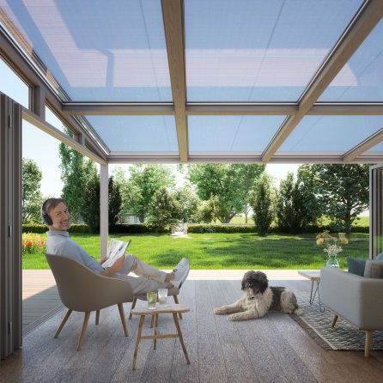
Image 2:
The Top conservatory awning is distinguished by the tried and tested clamping system, among other things.

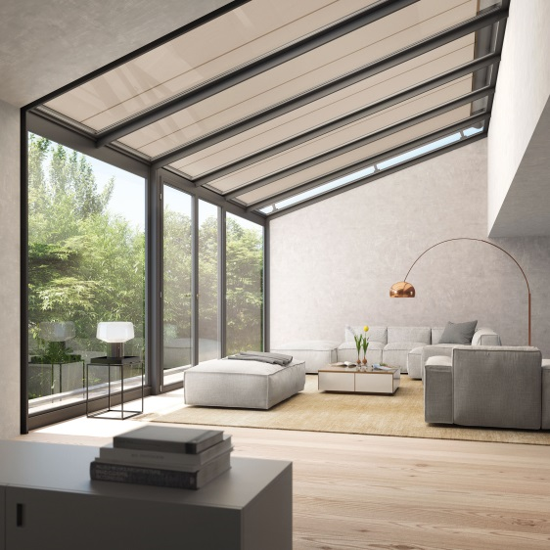
Image 3:
The Top conservatory awning can also be used for conservatories integrated into the house.
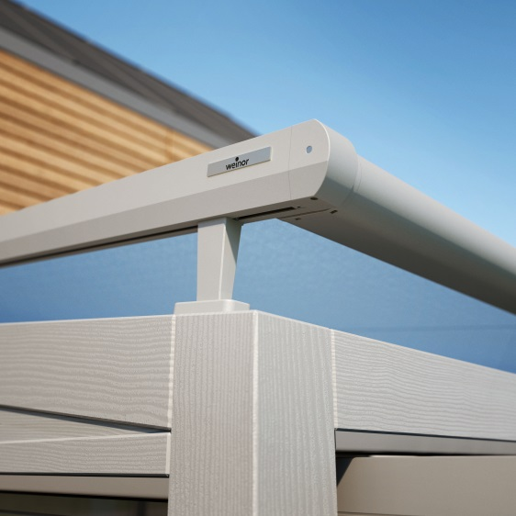
Image 4:
The height between the roof and awning can be individually adjusted
using different support brackets – depending on the technical building requirements.

Photos: weinor GmbH & Co. KG

