Press release
May 2017

Tempura Quadra heating system
Beautifully square

The new weinor Tempura Quadra heating system impresses due to its modern rectangular look and clever mounting base with integrated remote receiver. The small heater can be fitted anywhere without any problems.

Optional patio accessories offer trade businesses attractive additional business. That is why weinor has expanded its Tempura heating system. Besides the round version, there is now also a square design, the Tempura Quadra. Its highlights: modern design, a new low-glare tube and flexible panel mounting.

Slimline look
The Tempura Quadra's attractive design is not just due to its square style. It also cuts a fine figure thanks to its slimline look. This narrow construction comes from a clever technical idea. As the weinor heating system's newly developed base accommodates electronic components like a Hirschmann plug and radio control. They are both hidden out of view behind a faceplate. The compact box also gives the Tempura Quadra an unobtrusive, high-quality look.

Two versions – can be used anywhere
Tempura Quadra is available in two versions: for installation on the weinor Opal Design II folding arm awning and as the Tempura Quadra Universal for fitting to the wall or ceiling. As a result, it offers patio and balcony users a variety of possible applications.

Tried and tested quality
The Tempura Quadra is TÜV-certified and has been further developed based on the successful round version. The new square version therefore has the same plus points as before. These include, for example, the pleasant
infrared lamp's heat, regardless of the wind, and the high-quality finish. The new radiant heater can also be controlled either by the wired switch or using remote technology, just like the round system. Using the BiConnect radio from weinor, the appliance can not only be conveniently switched on and off using a hand transmitter but the heat intensity can also be dimmed.

New heating tube – low-glare instant heat
Tempura Quadra ensures maximum wellbeing and enjoyment on the patio with instant heat thanks to modern infrared technology. The heat is felt immediately on the skin, with no heating up phase and even with gusts of wind. Another bonus: Tempura Quadra is finished in the plant's own powder coating. This allows for high quality and a large range of colours. As a result, the box can be provided with the same coloured coating as the awning or patio roof frame.

Publisher:
Christian Pätz
weinor GmbH & Co. KG || Mathias-Brüggen-Str. 110 || 50829 Cologne
Email: cpaetz@weinor.de || www.weinor.de
Phone: 0221 / 597 09 265 || Fax: 0221/ 595 11 89

Contact:
Simone Lafrenz
Brandrevier GmbH || Gemarkenstraße 138a || 45147 Essen
Email: lafrenz@brandrevier.com || www.brandrevier.com
Phone : +49 (0)201 / 874293 13 || Fax: +49 (0)201 / 874293 29

This text as well as high-resolution images and other information are available at°www.weinor.de/presse/.

Image material:

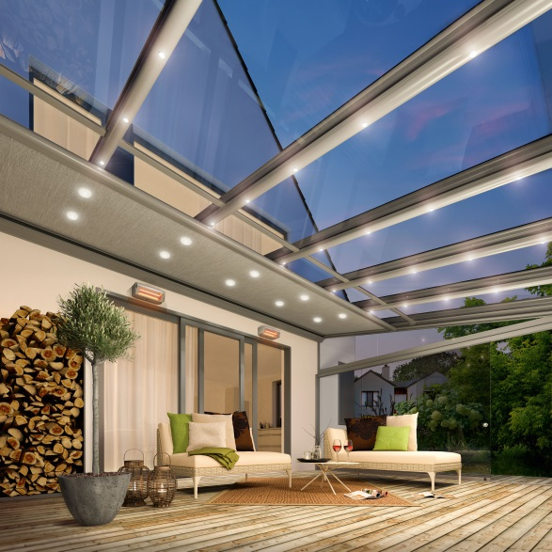
Image 1:
The new Tempura Quadra heating system can be fitted anywhere without any problems.

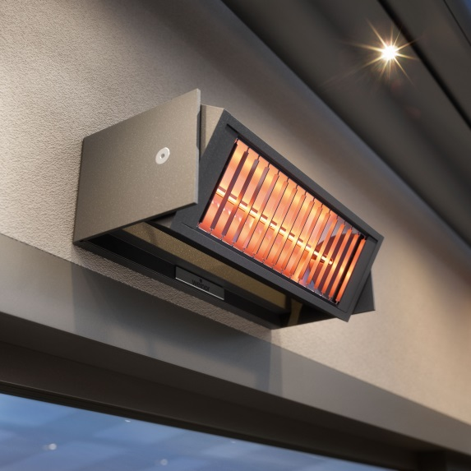
Image 2:
The compact heating system has an impressive look thanks to its modern square design.

Photos: weinor GmbH & Co. KG

