Sophisticated technology, modern design
PergoTex II is coming!
Closing the gap between the awning and patio roof - the water-proof Pergola system with folding technology is on the brink of its market launch.
New fabric-safety shield with drainage
The fabric-safety shield limits the levels of noise when it rains. In addition to this, a drainage system prevents water from dripping onto the fabric or the patio uncontrollably.
Straightforward cable laying for accessory products
weinor can optionally provide retailers with three mains connections for the VertiTex vertical awning and other additional electricity consumers.
Integrated LED lighting
The optionally available HighPower LED lighting is now incorporated in the cross-struts of the folding awning. Up to 48 spots can be integrated.
Easily accessible adjustments area
Servicing work is therefore easy to carry out on the control elements.
Problem-free integration of accessory products
The posts are now in a more square design. Fully glazed glazing elements and vertical awnings can therefore be mounted without stop profiles.
Modern design
PergoTex II stands out with its modern and clear design and features no screws in its visible areas.
New: Pergona translucent collection
The PVC awning is available in two versions: the Pergona classic collection consists of five patterns, one of which is new and has different colours on its top side and underside. The Pergona translucent collection is brand new, with a high light transmission of up to 21 %.
Weinor provides retailers with a wide range of advertising materials, so that when they sell the PergoTex II they are able to get off to a good start. Among other materials, these include a sample awning, roll-up and fabric collection. Those with insufficient space for a showroom sample are simply advised to order a large display.

Pictures
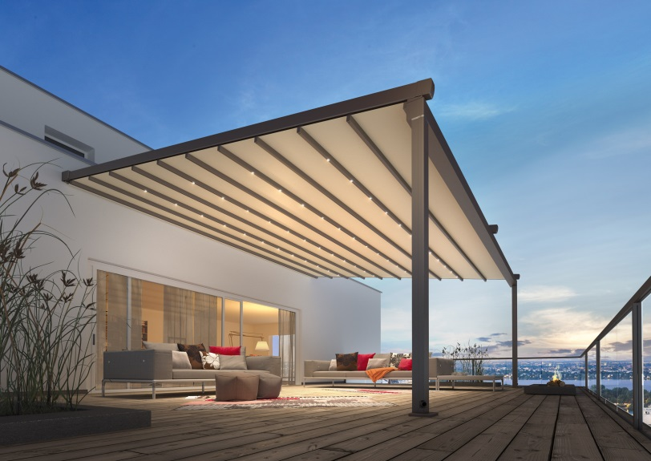
Weinor PergoTex II Pergola awning: The robust PVC awning material is rainproof, soil-repellent, wind-stable, and can also be opened at the touch of a button.

Picture credits: weinor

