Press release
January 2021

Terrazza Sempra: new glass patio roof from weinor
Proven technology, timeless design

The manufacturer weinor is launching another patio roof on the market.
Terrazza Sempra is based on the Terrazza Originale model, which has been tried and trusted over many years but has a linear look with posts and roof supports. The target group are building owners who want a modern design without having to give up the usual roof pitch.
Glass roofs have one crucial advantage over other patio roof constructions: they bring a lot of light to the patio. This is a clear advantage especially in northern and central European latitudes, as the days in the winter half of the year are relatively short and dark.

Clear lines, high stability
The new Terrazza Sempra from weinor comes just in time. It combines proven technology with timeless design. Because the weinor Terrazza Originale roof, which has been sold successfully for almost 20 years, served as the model. While the traditional roof is dominated by round shapes, Terrazza Sempra has an angular design. Roof supports, posts, guttering – clear lines are visible everywhere. Particularly imaginative: the roof supports, which are very stable due to their T-beam shape, are simply closed off at the front with a square cover cap to create a harmonious overall look. The glazing beads have also been visually adapted accordingly. What remains from the Terrazza Originale is the usual roof pitch. Here the Terrazza Sempra differs from the totally cubic weinor Terrazza Pure roof.

Clever details for easy installation
Many other technical details that have proven their worth in Terrazza Originale have been adopted for Terrazza Sempra. The square 115 post 115 with integrated downpipe and opening function for easy installation and maintenance is particularly practical for the fitter. In addition, the water outlet can be individually adjusted in height, depending on the structural conditions and the client's wishes on site. The 220 guttering also allows for up to 20 percent larger spans, depending on depth and snow load, without reinforcing the guttering with additional steel. This allows the client to enjoy an unobstructed view of the outside, without a central post. The steel reinforcement can be ordered loose and used on site, thus considerably reducing the transport weight and making installation easier. Terrazza Sempra can be installed in various roof shapes, for example for numerous types of pent roofs with wall offset or balcony cut-out. As a result, the specialist company can offer its customers tailor-made solutions and meet the on site requirements.

LED lighting, heating system, sun protection: top-selling accessories
For the Terrazza Sempra, weinor is now also offering the LED Design light strip in square design. If you want to bring colour to your customers' patios, we recommend the RGB Stripe LED strip with 48 colours and 3 shades of white. It can be flexibly installed on site, as can the Tempura Quadra heating system, which goes perfectly with the overall design line with its cubic look. No patio roof without privacy and sun protection: this is why the weinor VertiTex II vertical awning, the Sottezza II underlay awning and the WGM Top awning can be added without any problems. Everything can be easily operated with the BiConnect radio control.

Possible to extend to a cold-conservatory
If building owners want extended weather protection for their patio, specialist companies can easily fulfil this wish – with the custom-made full-surface w17 easy glass sliding doors. They can be quickly and easily closed to keep the weather out and just as easily opened again on warm days and can also be added to later on.

Media contact:
Christian Pätz
Weinor GmbH & Co. KG || Mathias-Brüggen-Str. 110 || 50829 Cologne
Email: cpaetz@weinor.de || www.weinor.de
Tel.: +49 221 / 597 09 265

This text as well as high-resolution images and other information are available at www.weinor.de/presse/.

Image material:

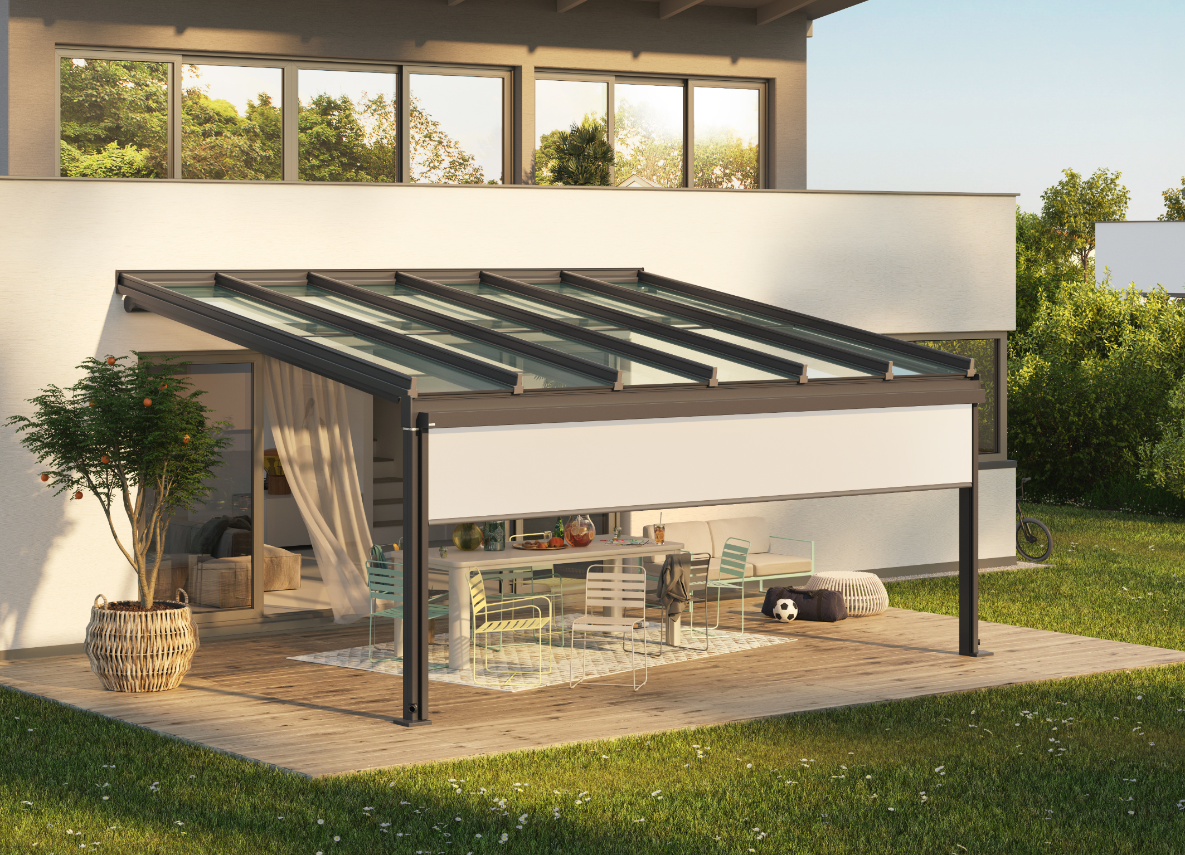
Image 1:
Timeless design: the Terrazza Sempra's look is impressive with its clear lines.

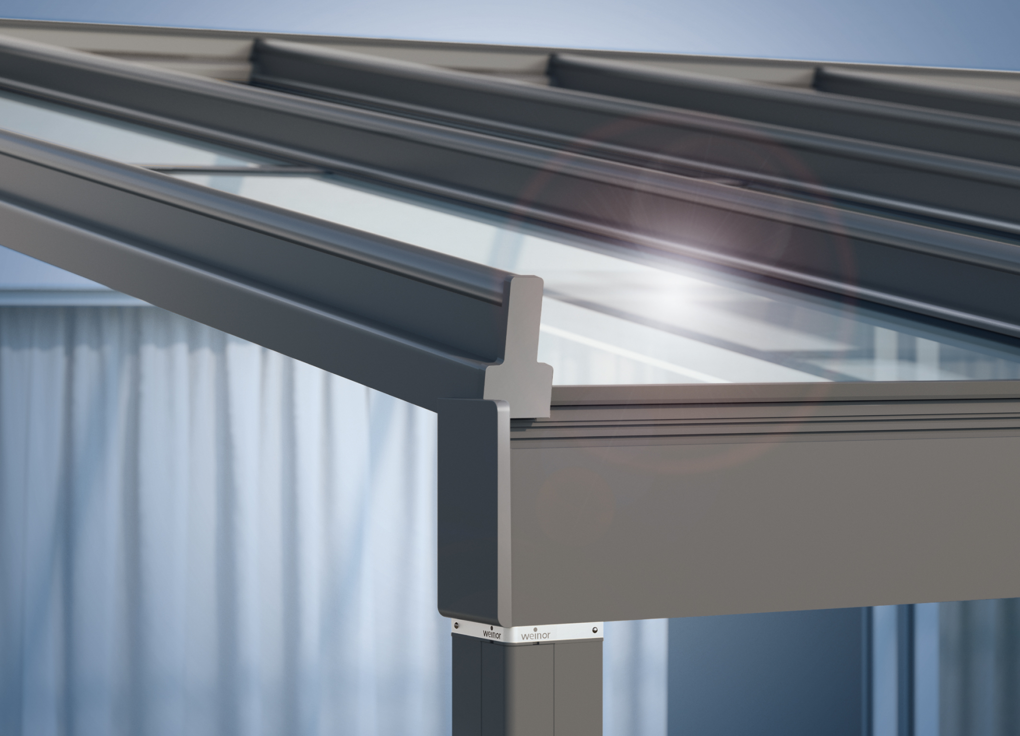
Image 2:
Proven technology: Terrazza Sempra is fitted with an extremely stable roof covering made of safety glass, which is particularly quiet in the rain, and has a solid aluminium construction.

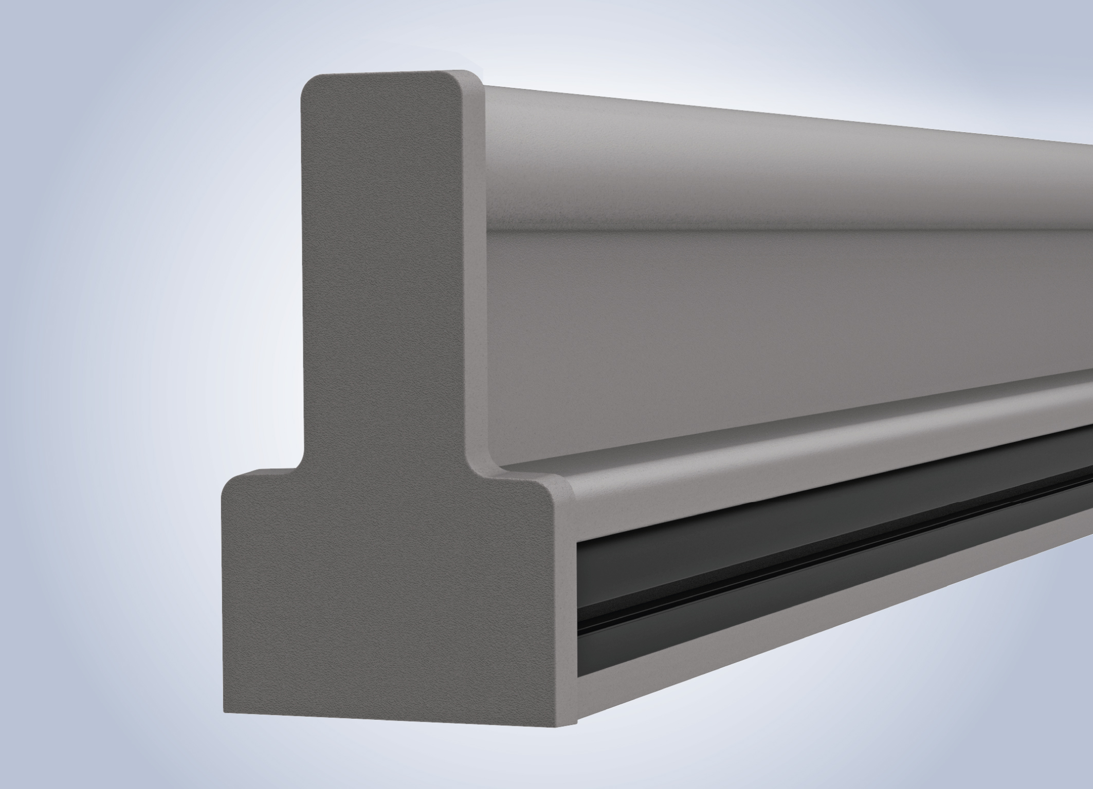
Image 3:
Due to the new shape of the cover cap and glazing strip, the stable
roof support has a linear, angular look.

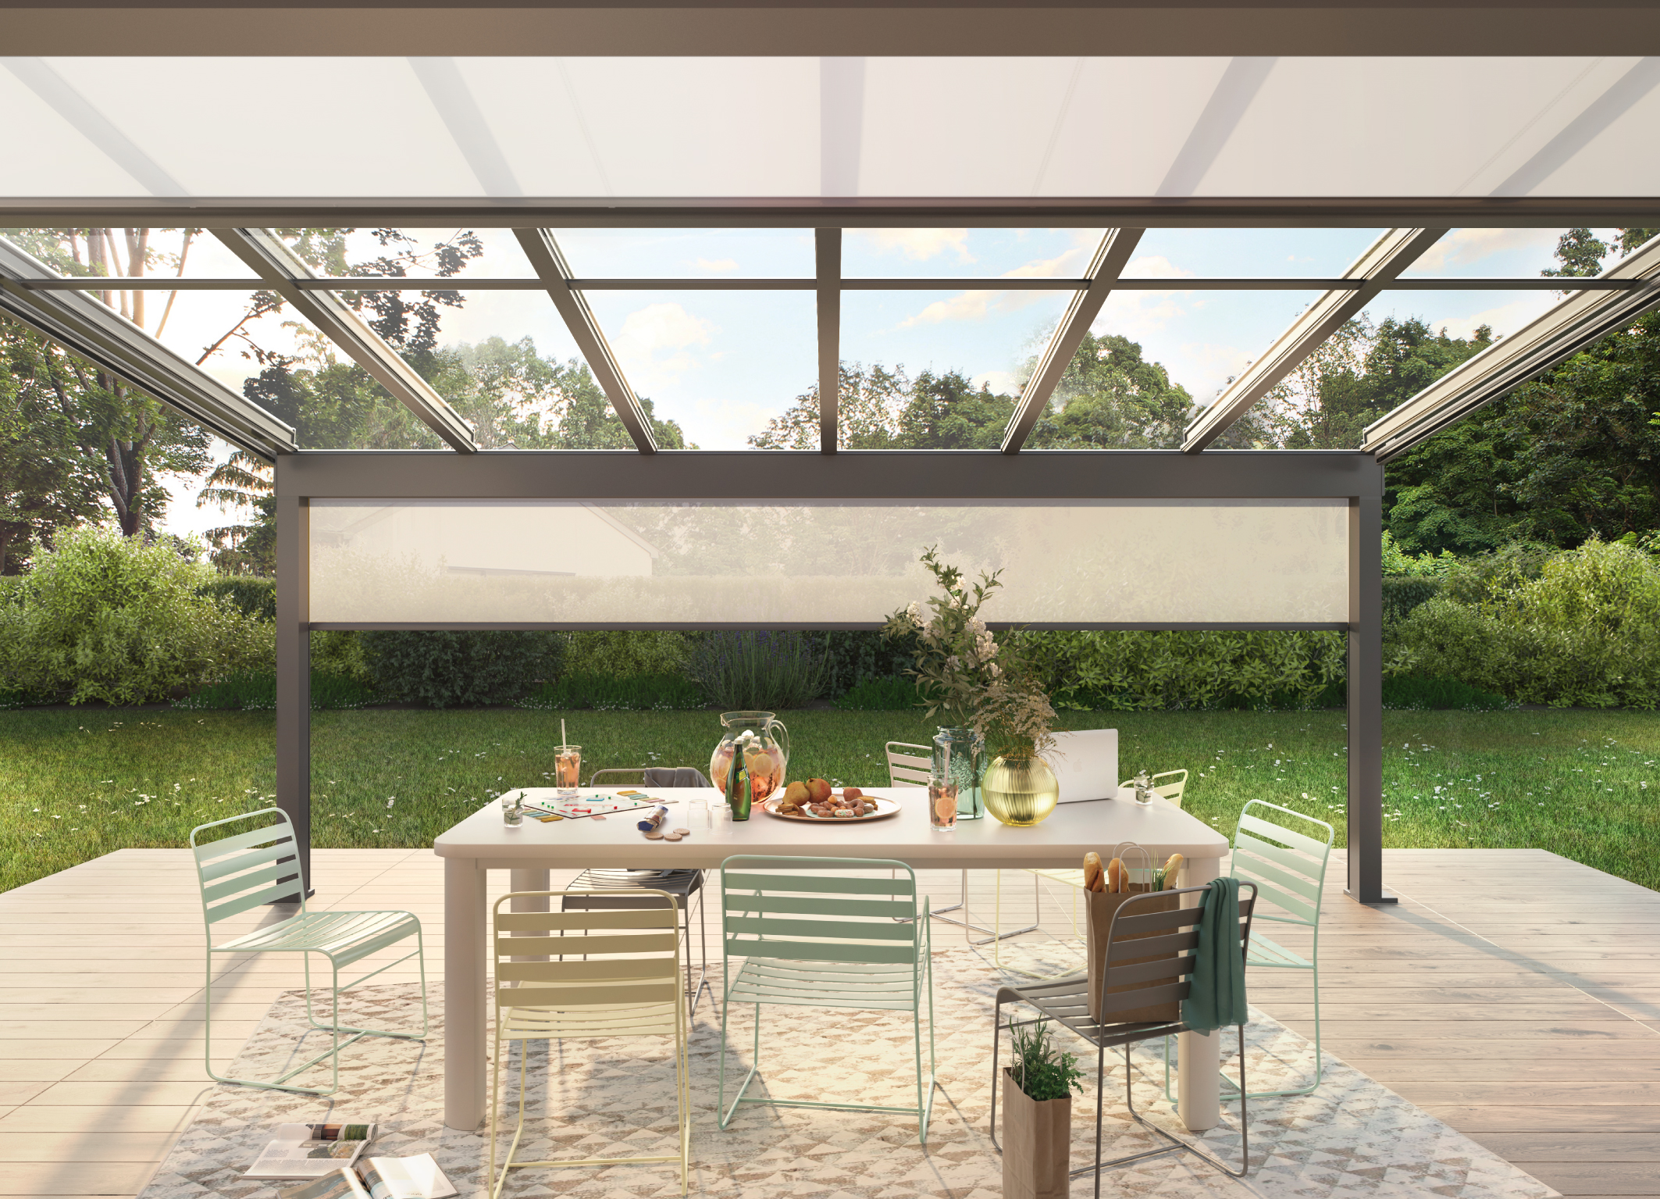
Image 4:
Terrazza Sempra can be supplemented with glazing elements, vertical and conservatory awnings as well as LED lighting and heating systems – retrospectively too.

Photos: Weinor GmbH & Co. KG

