Press release
May 2021

Red Dot Award, iF Design Award and Green Good Design Award
weinor impresses with top design several times

The new Terrazza Sempra patio roof from weinor convinced the jury of the iF Design Award with its linear design and timeless shape. The modern basics blue® sustainable fabric collection was a hit on several occasions. Having won the R+T Innovation Award and the R+T Sustainability Award, it has now won three awards: with the Red Dot Award: Product Design, iF Design Award and Green Good Design Award 2021.

The Terrazza Sempra glass patio roof won the iF Design Award with its straight lines and typical roof pitch. The timeless weather protection convinced the independent jury of 98 experts in particular due its high functionality combined with a clear design. There were a large number of contenders: this year, the jurors had to select the winners of the coveted seal of quality from among almost 10,000 entries from 52 countries.

Sustainability matters – to the jurors too

Only just on the market, it is already raining awards for the new modern basics blue® sustainable awning cloth collection with 85 percent recycled PET. The collection convinced the juries with its overall concept based on the resource-saving production process, combined with the highest quality, long-lasting colour brilliance and contemporary look. It comprises 16 modern designs in current trend colours for sophisticated outdoor living.

It was mainly the idea, function and social impact with which the sustainable awning fabric collection impressed the jury of the iF Design Award. modern basics blue® received the reddot winner 2021 award. "The winners of the Red Dot Award: Product Design 2021 particularly impressed me this year. The design of their products is excellent in terms of aesthetics and functionality. To hold your own in such a strong field of contestants and convince our jury is not easy. I therefore warmly congratulate the award winners on their success," said Professor Dr Peter Zec, initiator and CEO of Red Dot.

Having won the R+T Sustainability Award, modern basics blue® was able to win yet another award in the field of sustainability with the Green Good Design Award 2021. The awning fabric collection was awarded in the Green Product/Graphic Design category. The award for sustainable design is presented by the European Centre for Architecture Art Design and Urban Studies and the Chicago Athenaeum: Museum of Architecture and Design. Hundreds of contestants from 28 countries took part.

Sylvia Hendel, Head of Marketing at weinor, is delighted about the prestigious design awards. "We see the awards as an incentive to continue our strong focus on good design," says Hendel, "because the unique weinor overall concept always consists of the interplay of outstanding quality, first-class technology and excellent design."

Media contact:
Christian Pätz
Weinor GmbH & Co. KG || Mathias-Brüggen-Str. 110 || 50829 Cologne
Email: cpaetz@weinor.de || www.weinor.de
Tel.: +49 (0)221 / 597 09 265 || Fax: +49 (0)221/ 595 11 89

This text as well as high-resolution images and other information are available at°www.weinor.de/presse/.

Image material:

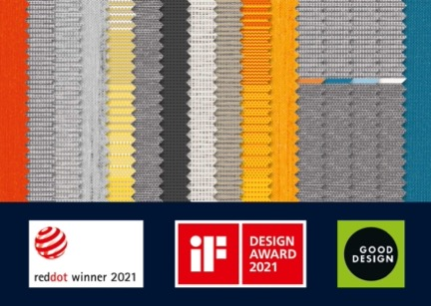

Image 1:
The modern basics blue sustainable awning cloth collection has received three awards.

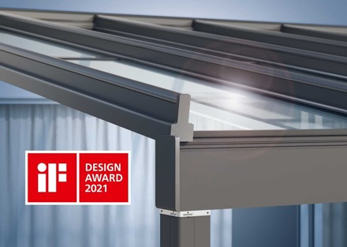
Image 2:
The Terrazza Sempra glass patio roof convinced the jury of the iF Design Award.

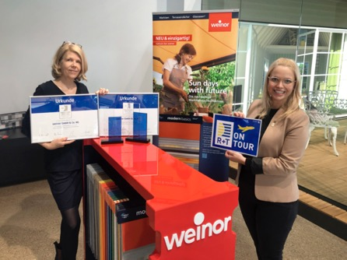
Image 3:
Vanessa Kunz, Head of Communications at Messe Stuttgart (right), presents weinor Head of Marketing Sylvia Hendel with the R+T Innovation Award and the R+T Sustainability Award.

Photos: Weinor GmbH & Co. KG

