Press release

New cubic cassette awning from weinor
Clean edges

The manufacturer weinor is launching a new generation of awnings on the market with Kubata. Its characteristic feature is the cubic shape of its cassette. Thus appealing to end customers who are looking for an awning to perfectly complement their modern house architecture. The reliable support pipe technology allows easy and fast installation.

Cubic shapes are a popular style element for contemporary facades. The new Kubata cassette awning integrates seamlessly into these. When open, the awning fabric impresses due to its high-quality, textile character.
When closed, the awning cassette creates clear lines on the building
with its almost square shape. Kubata's uniform shape is not without reason. It stems from an overall aesthetic concept dominated by smooth, screwless surfaces.

Tried and tested technology
Kubata is based on the I/K 2000 awning models from weinor, which have stood the test of time over many years. It has a support bar with more flexible mounting of brackets. This allows for fast and secure installation. The weinor LongLife arm, which the new cassette awning features, has also been working reliably for years. It has an impressively long service life and runs quietly. The wind lock safety device also protects against wind gusts from below. There is a new support profile for the Kubata's Opti-Flow-System which has a roller tube with floating bearing. This ensures the fabric is perfectly positioned. Kubata is supplied with a motor drive as standard.

Reliable drainage and removable cover plates
Besides the usual quality of the existing product characteristics, Kubata also boasts new details. For example, the drop profile is now equipped with a drainage system that reliably protects the fabric from getting wet when the cassette is closed. Two gutters collect the rainwater and channel it off sideways. The cover plates on both sides of the cassette can also be really easily removed using the clip technology. As a result, there is easier access to the control's cable connection and it is easier to carry out maintenance work.

Integrated LED lighting
Kubata can be supplied with LED spotlights that are integrated into the cassette as an option. The high-quality LED spotlights produce atmospheric lighting on the patio and have an operating life of up to 30,000 hours of lighting with very low energy consumption at the same time. The LEDs are very conveniently infinitely dimmable using the weinor BiConnect control.

Expected market launch in D, AT, NL, BE, LUX: May 2018

Media contact:
Christian Pätz
Weinor GmbH & Co. KG || Mathias-Brüggen-Str. 110 || 50829 Cologne
Email: cpaetz@weinor.de || www.weinor.de
Phone: 0221 / 597 09 265 || Fax: 0221/ 595 11 89

This text as well as high-resolution images and other information are available at°www.weinor.de/presse/.

Image material:

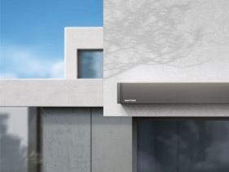
Image 1:
The new Kubata cassette awning from weinor impresses with its consistently cubic design.

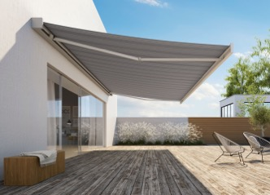
Image 2:
Kubata can be installed easily as a result of its support bar technology.

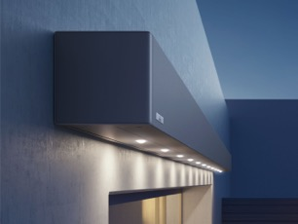
Image 3:
Kubata is optionally available with integrated LED spotlights

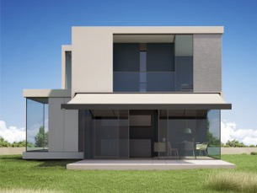
Image 4:
The drop profile is equipped with a new drainage system which protects the fabric from getting wet.

Photos: weinor GmbH & Co. KG

