Press release

Red Dot Award, Good Design Award, iF Design Award
weinor products showered with design awards

Three weinor products have been honoured with international design awards. The Tempura Quadra heating system received the Red Dot 2018 "Winner", the Good Design Award went to the undermounted conservatory awning Sottezza II and the w17 easy full glass sliding door. The latter also received the iF Design Award.

Right at the start of the year, the producer weinor is delighted with four design awards in total. The compact, cube-shaped Tempura Quadra heating system can now also be included among the weinor products that have received a design award. It was honoured with the Red Dot Award "Product Design 2018" as the "Winner" in the Heating and Air-conditioning Technology category for its high design quality. As a result, the Tempura Quadra won a competition with entries from more than 59 countries.

The Good Design Award has been presented for 68 years and is one of the oldest international design awards. Now the undermounted conservatory awning Sottezza II and the w17 easy full glass sliding door have the honour of accepting this award too. w17 easy also won another award. It picked up the iF Design Award "Winner", issued by roughly 60 renowned design experts from more than 20 countries, in the "Garden" category. Together with the Red Dot Award and the German Design Award, the full glass sliding door has therefore already received four prestigious awards in total now. The four new design awards are an addition to the respectable collection of 25 design awards in total that weinor products have accumulated over the last few years.

Media contact:
Christian Pätz
Weinor GmbH & Co. KG || Mathias-Brüggen-Str. 110 || 50829 Cologne
Email: cpaetz@weinor.de || www.weinor.de
Phone: 0221 / 597 09 265 || Fax: 0221/ 595 11 89

This text as well as high-resolution images and other information are available at°www.weinor.de/presse/.

Image material:

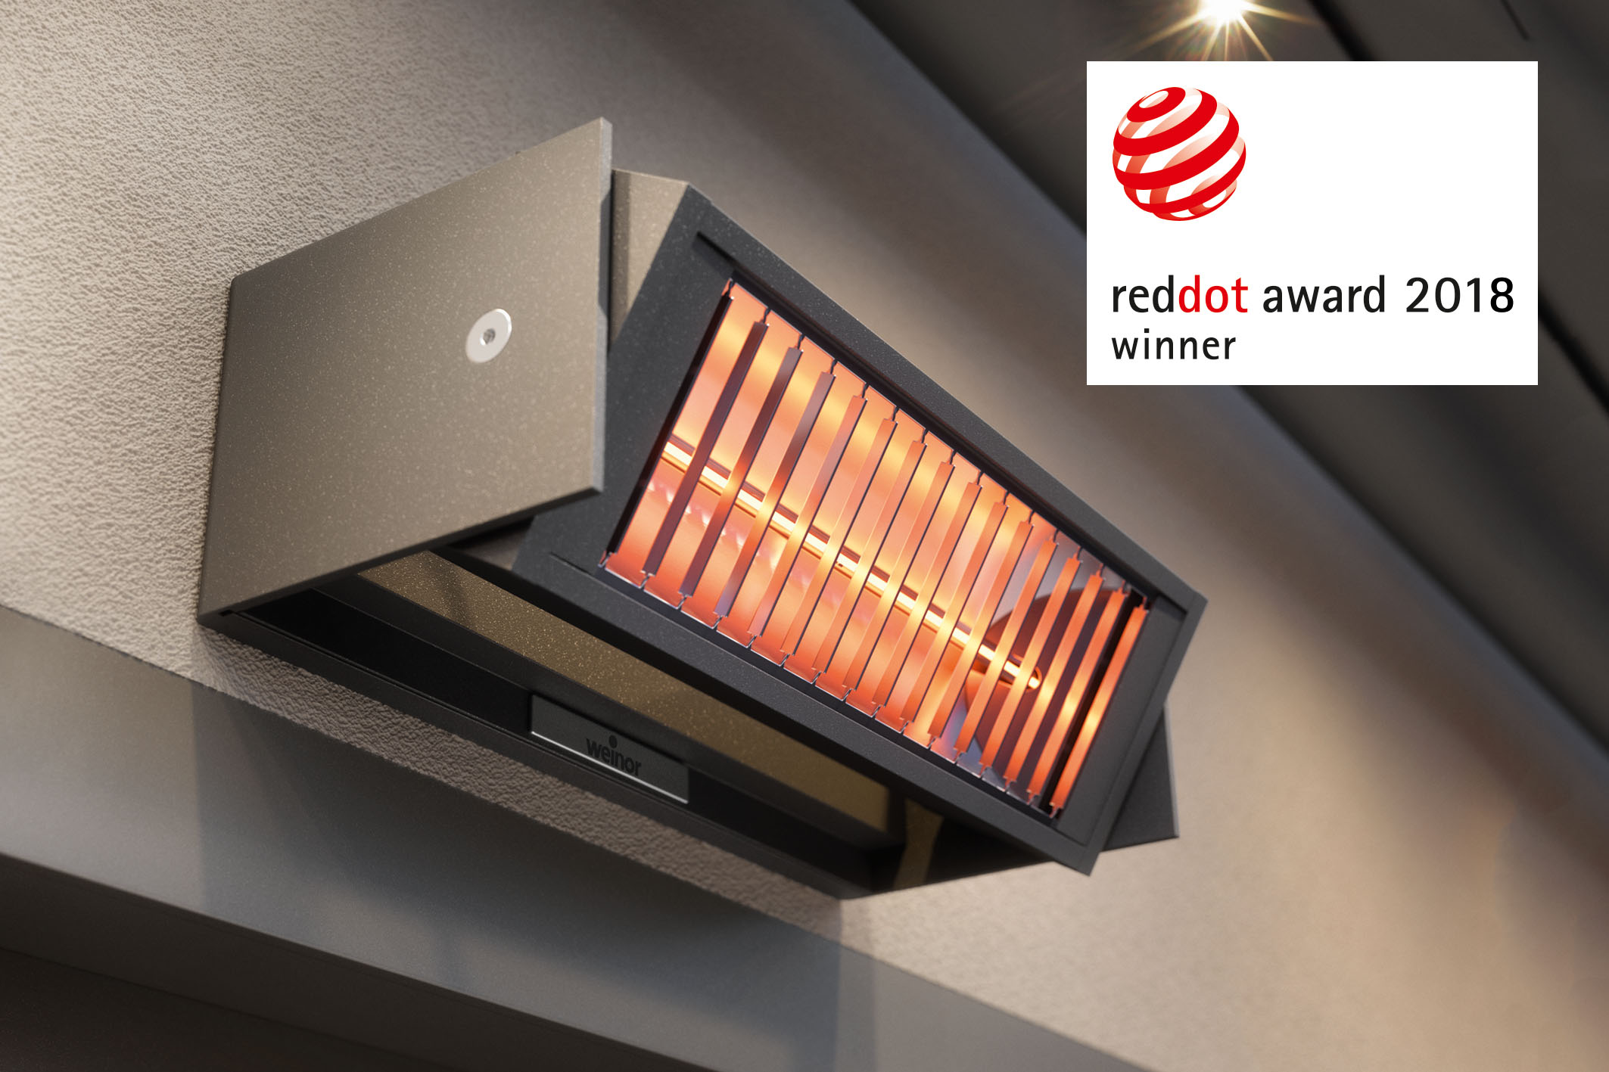
Image 1:
The Tempura Quadra heating system received the Red Dot Award "Winner".

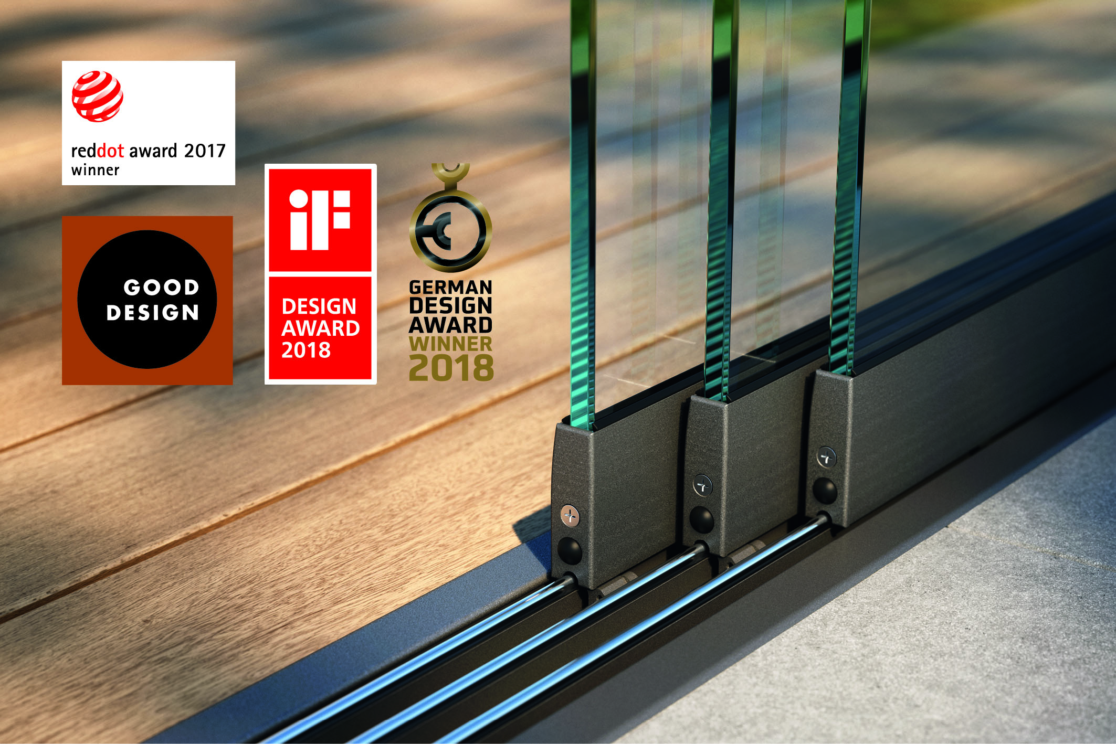
Image 2:
The w17 easy full glass sliding door was honoured with the Good Design Award and the iF Design Award.

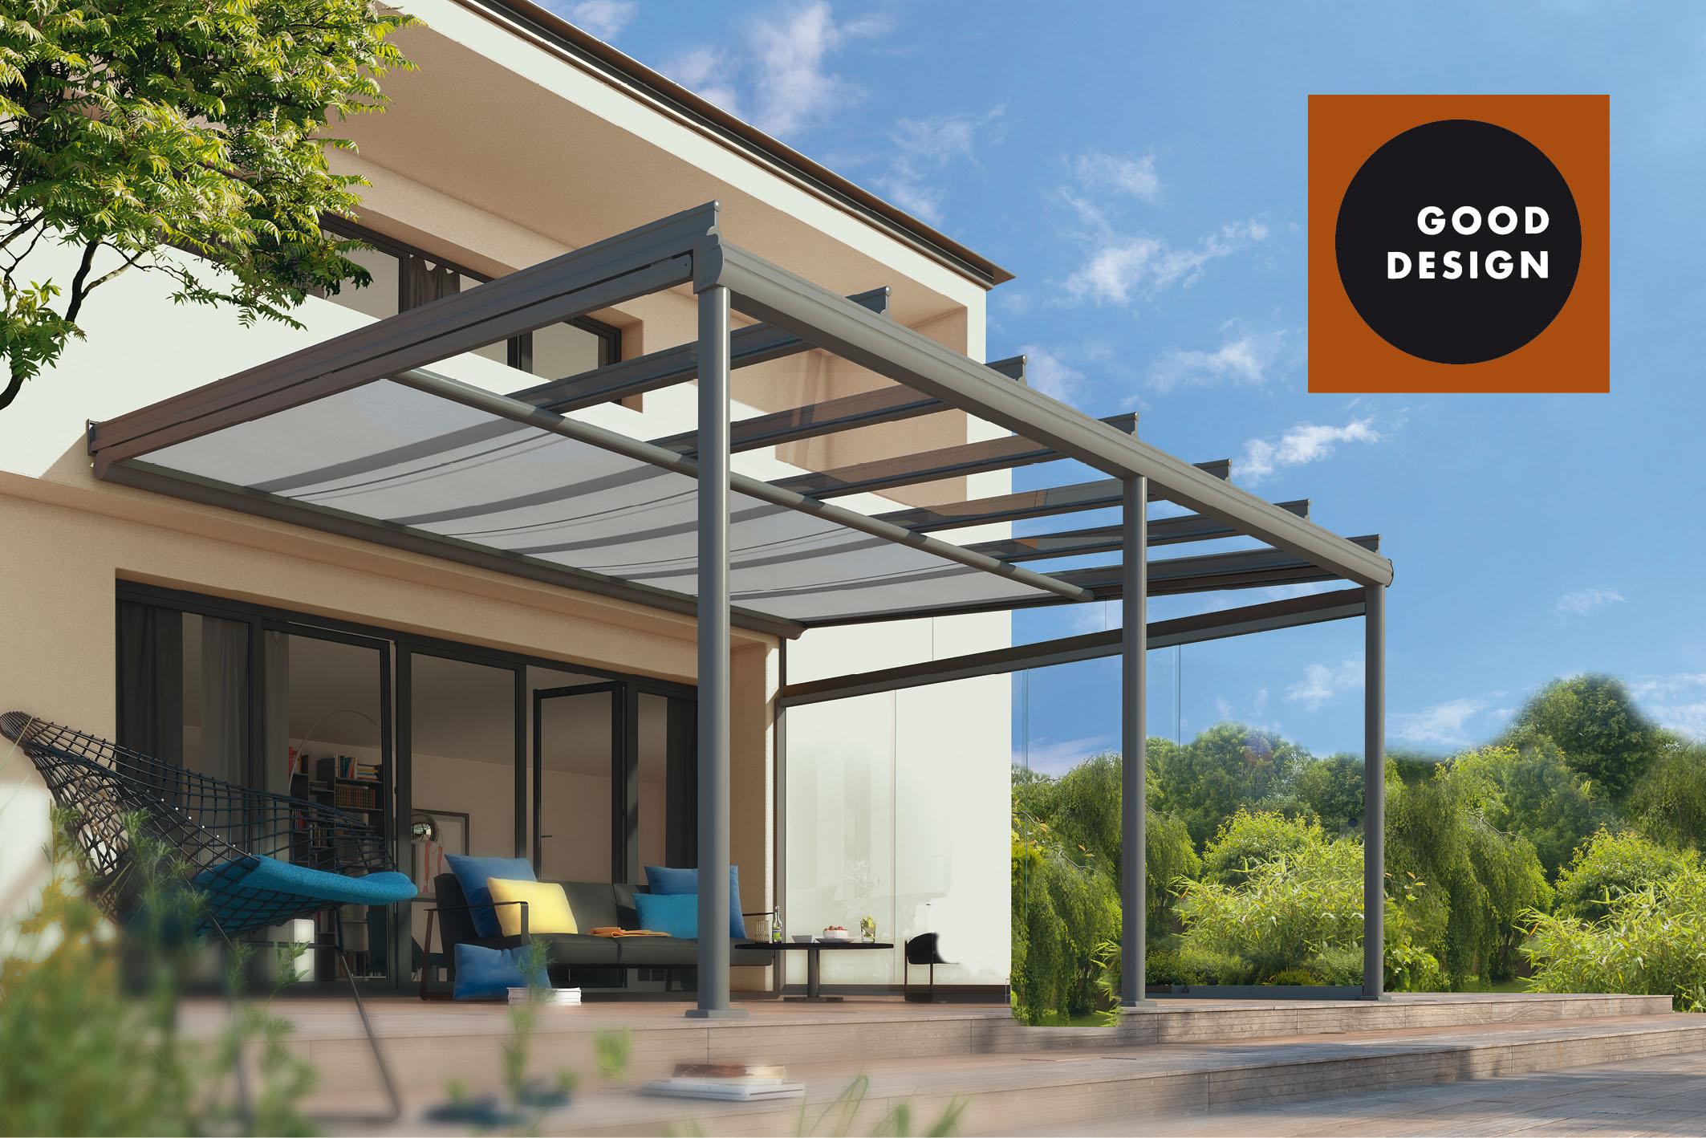
Image 3:
The undermounted conservatory awning Sottezza II picked up the Good Design Award.

Photos: weinor GmbH & Co. KG

