Press release
April 2023

Successor to Thilo Weiermann
Tim Füldner has been appointed as Weinor Managing Director as of 2024

Sun and weather protection specialist Weinor has found a new Managing Director. The 53-year-old Tim Füldner will start at Weinor on August 1, 2023 and manage the Cologne manufacturer’s business following a settling-in period as of the beginning of next year.

Weinor had already announced at the end of 2022 that its Managing Director of many years’ standing, Thilo Weiermann, will retire at the end of 2023. Now, the company has found a successor in good time. Tim Füldner will start his work at Weinor as of August 1, 2023. The trained Diplom-Betriebswirt [business economist] has spent the majority of his career in management positions at renowned companies within the construction elements sector. Thus, for example, he worked as the Sales and Marketing Manager for the company Hydro Building Systems, which also owns the aluminium systems company Wicona. Moreover, he worked as the Chief Executive Officer at Butzbach GmbH Industrietore. His latest post was as a member of the extended Executive Management Board at Schüco KG. He was also responsible for the Business Unit Doors and Fire Protection Systems and as the Managing Director of the subsidiary company Sälzer GmbH there.
He will be familiarised with Weinor between August and December. During this period, Thilo Weiermann will retain his responsibility as the Managing Director. Then, Tim Füldner will assume his tasks. “Due to his experience and know-how, I am certain that Tim Füldner is a great asset for Weinor and will continue the close-knit and successful collaboration with our partners resolutely”, as Weiermann explains.

Media contact:
Christian Pätz
Weinor GmbH & Co. KG || Mathias-Brüggen-Str. 110 || D-50829 Köln
E-mail: cpaetz@weinor.de || www.weinor.de
Tel.: +49 (0)221 / 597 09 265 || Fax: +49 (0)221/ 595 11 89

Image material:

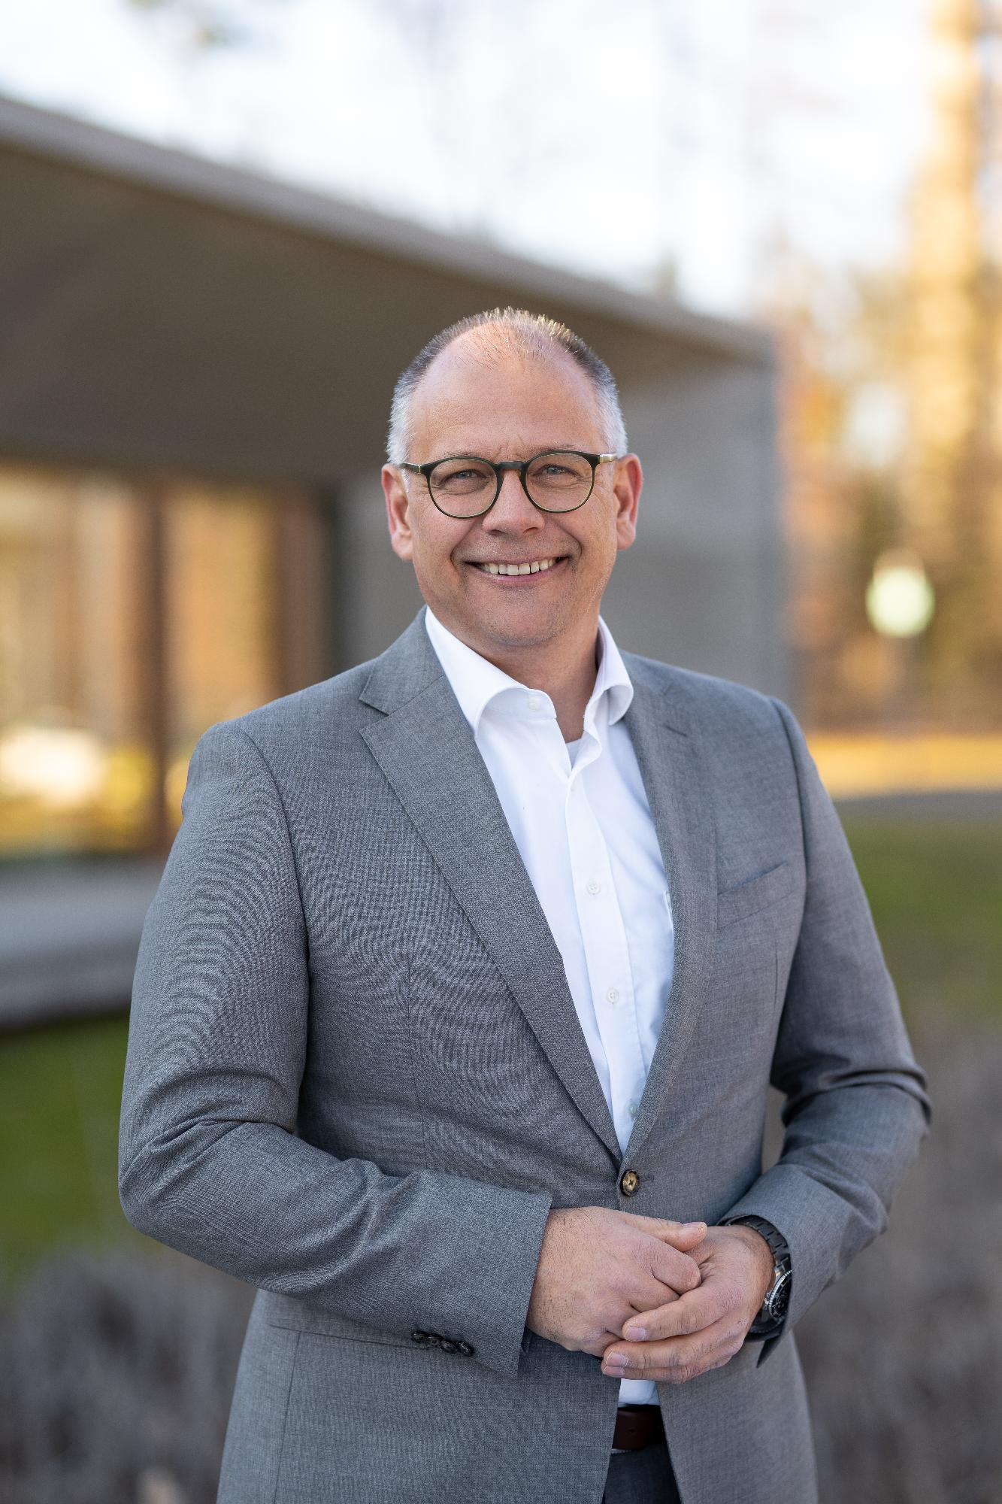
Image 1:
Tim Füldner will be the Weinor Managing Director as of January 2024.

Photo: Weinor GmbH & Co. KG

