Press release
30 June 2017

New w17 easy glass sliding wall from weinor
Quiet and easy to move

weinor is launching the successor to its w17-c easy-glide sliding wall on the market, the w17 easy glass sliding wall. It is suitable to be fitted under almost all kinds of roofs and impresses due to its simple installation, easy cleaning and convenient operation.

Glazing elements mean attractive additional business for trade companies. As patio roofs, pergola awnings or balconies and loggias can be quickly and easily transformed into an outdoor area protected from the weather all round with them. weinor has optimised its current system to make this business even easier for its retailers and partners. The result: a new glass sliding wall with several clever benefits.

New soft closing system
The w17 easy glass sliding wall is equipped with the soft-closing system as standard. It allows the glass leaves to move extremely quietly and easily. This allows them to be opened and closed quickly and safely.

Easy cleaning, accessible transitions
The w17 easy's other benefits include new floor rails and floor attachment profiles. With the floor rails there is a standard version with 26 millimetre visible height. It has something very special to offer: the CleanCase. This is a cavity at the end of the rail. Dirt can be really easily swept into the CleanCase using a hand brush or cleaning cloth and then disposed of outside through an opening. Water can also be reliably drained through the CleanCase. weinor also still offers an optional flat rail with 13 millimetre visible height. It allows for an accessible transition from inside to outside – an important plus point that can be crucial for many end-users in their decision to buy. A perfect transition to existing surfaces is also possible with two floor attachement profiles in angled and straight versions.
Attractive look – clever locking
The glass sliding walls can be fitted with high-quality handles, powder coated or stainless steel, a lockcase and standard locking. The design of the handles, profiles and lock is based on the trend of modern, clear lines and screwless look. weinor has developed simple and robust interlocking so that the whole closed glass leaf remains reliably in the required position. Slight pressure with your foot is all it takes to securely lock the w17 easy and open again. Be it handles, lock or profiles: the entire construction can be coated uniformly in more than 200 colours and therefore the look can be adapted perfectly to the existing architecture.

Can also be used indoors
w17 easy is not just for use on patios. The glass sliding wall is also suitable for indoors – as an elegant room divider, without any anti-stumbling thresholds. Turning a small room into a large one with just one simple action. An opaque but translucent glass with velvet matt surface is also available as a satin-finished version.

Media contact:
Christian Pätz
weinor GmbH & Co. KG || Mathias-Brüggen-Str. 110 || 50829 Cologne
Email: cpaetz@weinor.de || www.weinor.de
Phone: 0221 / 597 09 265 || Fax: 0221/ 595 11 89

Image material:

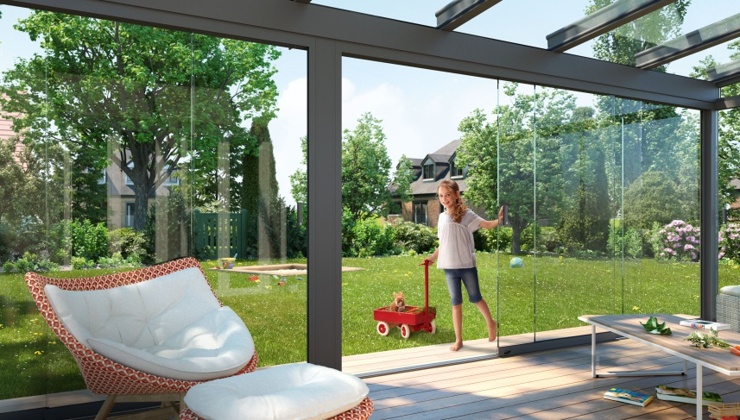
Image 1:
The new w17 easy glass sliding wall can be moved easily and quietly – thanks to the soft closing system.

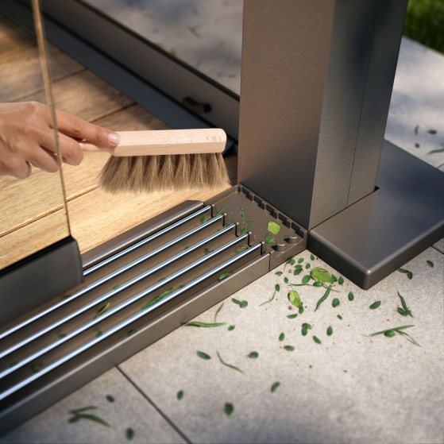
Image 2:
The CleanCase from weinor integrated into the running rail makes the construction easier to clean.

Image 3:
The w17 easy can be really easily locked and unlocked using your foot.

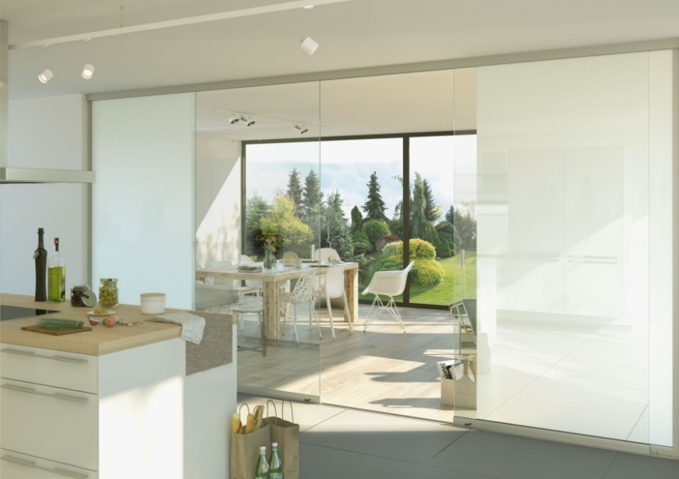
Image 4:
The w17 easy glass sliding wall can also be used indoors as a room divider – with no stumbling hazards at all.

Photos: weinor GmbH & Co. KG

